**Rise and Fall of the Aam Aadmi Party**

Sree Iyer

00.78.00

Foreword

The advent of Social Media has resulted in greater transparency. Be it Politics or Corruption or Journalism, it is becoming increasingly difficult to hush up scandals. It has also resulted in wide dissemination of Fake News but in time, this will subside. There are several signs that Social Media platforms are cracking down on Fake News, pulling down pages when they cross the line and so on.

Arvind Kejriwal’s dreams of being a Political leader perhaps started with him being invited by Gurudev Sri Sri Ravishankar to be part of the Art of Living’s (AoL) The March Against Terrorism Against Corruption on March 1st, 2009.

In a conversation with me, Gurudev described how he had approached Kiran Bedi, then Arvind Kejriwal and subsequently Anna Hazare, as he had seen Anna’s successful movement against corruption in Maharashtra to raise the awareness of people against corruption.

He also recounted how Arvind Kejriwal slowly started hijacking the movement, especially after the India Against Corruption (IAC) was formed and taking control of its financing and messaging. As the movement grew and attracted the common man, AoL slowly withdrew from the IAC. In his opinion, he said that with Kapil Mishra’s allegations, AAP is more or less finished.

This book is an analysis of AAP’s meteoric rise and fall. Whether it will completely get decimated or rise back from the ashes like the Phoenix, only time will tell.

Table of Contents

Origins of a fantasy 7

It all began when… 9

The Arab Spring 14

Arvind Kejriwal, the Blue Fox of Indian Politics 25

Wednesday, October 5, 2016 33

Unholy alliance with Congress 41

Rampant Money Laundering and Corruption 48

Minister Satyendra Jain’s money trails 51

AAP’s fraudulent Accounting practices - **ReceiptGate** 53

Kejriwal’s brother-in-law caught 56

Lies of Kejriwal 58

Brouhaha over the CWG Scam report 59

Saying something and doing the opposite… 60

Media parroted Kejriwal’s lies 60

Avoided attacking Tata 61

Frivolous lawsuits 62

Selective mud slinging 63

Give Ads, buy their silence! 64

State Unit leader falls to his death 65

Kick away the ladder 67

What goes up… 68

Role of media in promoting Arvind Kejriwal 70

Kejriwal as PM?! 70

Yogendra Yadav as Haryana CM? 71

Varanasi Lok Sabha election 71

Caught in the act 72

AK as Opposition candidate for PM? 72

Paid Advertisements lack civility 75

What about the poor voter of Delhi? 75

Odd-Even plan for regulating traffic 77

Fishing in troubled waters 77

Unrest in Delhi’s JNU 79

Modi for India and Kejriwal for Delhi 80

Debacle in Punjab and Goa 82

Blame the EVM 84

Chasing TRPs 85

Delhi MCD elections 87

Aftermath of the MCD elections 88

Kejriwal’s trust deficit 91

I, me and myself 92

Kumar Vishwas – in, looking out? 94

Saga of the 21 MLAs 96

Plagiarism charges 97

Covering all the bases 98

Where does AAP go from here? 100

INDEX 101

Table of Figures

Figure 1. Details of Rs. 90 lakhs donated by Priya Bansal 55

Figure 2. AAP bungling of accounts 56

Figure 3. Kapil Mishra lays bare Kejriwal's corruption 69

Figure 4. Nothing left for the city! 76

Figure 5. Zero seats in Goa! 83

Figure 6. AK challenging PK! 85

Figure 7. TRP Magic formula 86

Figure 8. Dengue threat to the Delhi Public 88

Figure 9. Modi squashes Kejriwal in MCD elections 89

Figure 10. Washing dirty linen in public 90

Figure 11. A temporary truce 95

# Origins of a fantasy

The average life span of a Male mosquito is 10 days. Houseflies live for 28 days. The Aam Aadmi Party (AAP) may end up having the dubious distinction of being one of the shortest-lived political parties in India, to gain and lose people’s mandate so quickly. This party is a typical example of how people can be fooled and lured into believing in an alternate universe with tall claims and white lies. It also shows the public’s revulsion against the existing national parties and their willingness to give an earnest sounding party a chance. AAP and its supremo Arvind Kejriwal was the face of media owners, who were basically anti-Bharatiya Janata Party (BJP). To keep the pot boiling, AAP was propped up by some journalists, who too liked the status quo and were afraid that in a BJP dispensation, they may be found out. As this narrative unfolds, you will also see how AAP was the B-Team of an existing party.

AAP was born out of the massive anti-corruption movement witnessed in India, after the 2G Scam was blown out of proportion[1] by December 2010. People’s anger against the ruling Congress party based coalition had not diminished even after the exit of the tainted Telecom Minister A. Raja[2]. This anger found expression in their support for the non-political outfit, India Against Corruption (IAC).

The Supreme Court was also rapping the United Progressive Alliance (UPA) Government on a daily basis on the 2G scam and the Report of Comptroller and Auditor General (CAG) estimating a possible loss of Rs.1.76 Lakh Crores to the exchequer really fired them up. The legal battles of the then Janata Party leader Subramanian Swamy and activist lawyer Prashant Bhushan were the igniting points of this anti-corruption wave.

When these two ideologically different mavericks (Swamy and Bhushan) were fighting their battles in courts, an organization known as IAC was staging small protests in Delhi’s Jantar Mantar, the allocated area for demonstrations on the rampant corruption in the Commonwealth Games (CWG). After the games were over in October 2010, the protests were losing steam. And many media houses had got their advertisement booty of the CWG and were dialing back on corruption reports in the games. But the Apex Court’s intervention, the CAG Report and Telecom Minister’s resignation were a telling indicator. People were furious. This was the beginning of the end of the Congress regime.

The Rashtriya Swayamsevak Sangh (RSS), Sri Sri Ravi Shankar’s Art of Living and Baba Ramdev were urging the masses to raise their voices against the humongous corruption[3] cases of the Congress led UPA-2 government. The BJP which was hibernating after losing the 2009 Lok Sabha elections slowly started energizing.

### It all began when…

Gurudev Sri Sri Ravishankar started the ball rolling with a resolution to gather 5,000 Art of Living (AoL) volunteers on March 1st, 2009 to assemble and protest against terrorism and corruption. Titled **The March Against Terrorism Against Corruption**, AoL had invited Arvind Kejriwal and others such as Mr. Bitta, Mr. Prahlad Kakkar and Mr. Anirudh Bahl.

Around 10,000 gathered that day to march from Parliament Street to India Gate. Chants of “Inquilab Zindabad”, “Youth for Equality”, “Himmat hai to saath chalo…” filled the air. Kejriwal even came up with a tag line, “free the country from the **Black British**”!

Seeing the success of the event, Sri Sri enlisted Kiran Bedi, then Kejriwal and reached out to Anna Hazare. AoL was committed to bringing the crowds to the IAC meetings while it was expected that someone clean such as Anna Hazare and Kiran Bedi, would manage the event. How Kejriwal managed to hijack this and reap political dividends from this is a fascinating story.

India was waking up to a new scam almost every day. The rampant corruption in the Sonia Gandhi controlled UPA-2 government was drawing many activists to try and mobilize. Many meetings were convened across the country by groups ranging from the Left to the Right ideologies, while the common man started slowly started participating in the protests. Many activists belonging to Sonia Gandhi’s camp like Aruna Roy, who were part and parcel of National Advisory Committee (NAC), started distancing themselves from the NAC and speaking against corruption. Roy eventually left the NAC in 2013[4].

Those days Arvind Kejriwal was considered as an acolyte of Aruna Roy. He was nursing an ambition to become a Member in the NAC headed by Sonia Gandhi when UPA-2 resumed power in 2009. But it was shot down by many in Congress and Arvind Kejriwal slowly started distancing himself from Congress and began getting involved in protests against corruption in CWG along with Kiran Bedi and the IAC. Perhaps it hurt his ego that his contemporary Yogendra Yadav was a member of the NAC and he couldn’t get in.

Christian organizations were entering into the anti-corruption movement and Delhi Archbishop Vincent Concessao, who is considered to be close to Sonia Gandhi also joined in the protests. They were cleverly insulating Sonia Gandhi from the corruption occurring in the UPA-2 and putting the blame on Prime Minister Manmohan Singh. The pot was working overtime to call the kettle black.

But the RSS and Subramanian Swamy directly attacked Sonia Gandhi and blamed her for all the graft in the UPA-2 Government. Many media houses also openly started supporting the anti-corruption movement by this time. Was media used to keep the blame at UPA’s doorstep and make Sonia appear above the graft? Read on...

Suddenly a viewpoint that India needs a system called Lokpal to check the corruption in the government started gathering momentum. Words like “Independent” Ombudsman or Lokpal were floating in the air by early 2011. By February, many prominent activists assembled in Mizoram to strategize anti-corruption movements in the country. Sonia’s friend Aruna Roy and her team started advocating for a peaceful campaign and stress for the implementation of a Lokpal system. But agitated members argued for protests in the streets and at last a decision was taken to stage a huge gathering in Jantar Mantar by April 2011. Sensing the mood of the gathering, Arvind Kejriwal left his mentor Aruna Roy and jumped in with both feet, with the people who argued for street protests and hunger strikes.

Then the question of who will lead the protests came up. Anna Hazare, who had been spearheading anti-corruption movement in Maharashtra, was persuaded to be the face of the movement. Anna had also successfully got Right To Information (RTI) implemented in Maharashtra. Liberal activists sensed that his Gandhi Cap and Khadi dress will be irresistible and would draw huge crowds. Rustic Anna Hazare was falling into the hands of the urban activists like a puppet. Seeing so much “support” from people who routinely showed up on TV perhaps made Anna to agree for a fast unto death till the Government agrees for the introduction and passing of Lokpal Bill in Parliament in the forthcoming Session. All the activists argued for a non-political platform.

The Liberal activists (termed *Liberati* from this point forward) were very clever in avoiding the 2G Scam crusader Subramanian Swamy from their plans, terming him as a politician and only accommodated the other 2G petitioner and noted lawyer Prashant Bhushan. Sensing this, Swamy from the very first day argued that Lokpal and all its trimmings were fantasies and that the current system has enough teeth and the need of the hour is people with integrity in power. He kept his guns trained at the Sonia family and toured the country, addressing programmes mostly organized by the RSS, advocating the need for voting out the Sonia led Congress regime, while the Liberati kept a stony silence on uttering the name of Sonia Gandhi.

All the preparations were going on to conduct a fast-unto-death by Anna Hazare in April 2011 and by March several media organizations and their owners suddenly became the supporters of the anti-corruption crusade[5]. Journalist Rajdeep Sardesai and his colleague Ashutosh were blatantly supporting the anti-corruption protests. They forgot that this could be construed as a conflict of interest with their profession, to be objective as a journalist. Both were senior editors with Mukesh Ambani controlled CNN-IBN network at that time. The illustrious duo never uttered a word against 2G or KG Basin scams!

Only NDTV’s Barkha Dutt could not jump into the fray, as her currency had devalued considerably because of the Niira Radia tapes[6] expose. Such was the public anger on her that she was shooed away when she came to conduct a live show during Anna Hazare’s protest. Ironically she got a lease of life, when Arvind Kejriwal later started giving her “exclusive interviews”.

Kejriwal was supported by NDTV from 2006 as an RTI activist. NDTV was the partner of his show called 'RTI awards' till 2010. He was hyped as India's RTI man, while ignoring several noted RTI activists such as Subhash Agarwal[7]. Kejriwal returned the favor by never mentioning NDTV's role in Niira Radia tapes, while he spoke about Niira Radia tapes everywhere in every function. The art of compartmentalization by politicians is a science of its own – what to tell whom, what not to tell, when to stroke someone’s ego, when to toot one’s own horn and so on.

### The Arab Spring

Meanwhile across Asia and Africa agitations were going in non-democratic countries like Tunisia and Egypt and many US agencies were supporting and fueling these protests. The Liberati tried to compare the Jantar Mantar strikes with those in Tahrir Square or the Jasmine Revolution. Many journalists like Rajdeep Sardesai were egging Kejriwal to conduct these types of TV friendly protests. Sardesai himself on many occasions advised Kejriwal and Kiran Bedi to go for Egypt’s Tahrir Square[8] style of protests by putting a lot of people at public places for days and days till the Government agrees to their demands. Irony is people like Rajdeep Sardesai, who supported the UPA Government and never reported any of its major scams like 2G, Coal scams became the advisors of anti-corruption movement! Objectivity? What does that word even mean?

Ford Foundation and many Scandinavian based Non-Governmental Organizations (NGO) covertly supported by Churches were funding Kejriwal and his acolytes from early 2000. Many NGOs floated by Kejriwal and Sisodia were funded by the Ford Foundation. No accounts were submitted to Government on this regard by these people. Sisodia even tried to explain it away to Home Ministry’s FCRA Division that their accounts were lost during house shifting. More in the coming chapters on this.

By the first week of April, Anna Hazare started a fast-unto-death for Lokpal Bill[9]. Arvind Kejriwal and his deputies Kumar Vishwas and Manish Sisodia became the stage managers, mike operators of the venue and fund collectors, leaving Anna to fast. Many urban naxals also joined the strike and came up with slogans against all political parties, though majority of the masses were from Right Wing organisations like the RSS, Baba Ramdev & Sri Sri Ravi Shankar’s Art of Living.

It must be noted that Right Wing think-tank Vivekananda International Foundation headed by Ajit Doval was very active in strategizing these protests. But urban naxals like Kejriwal and pro-Congress, Left, Liberal persons were also playing their part in controlling the agitation when common man started showing interest. No politician was allowed to arrive at the function. This was a clever ruse by the Urban Naxals to keep the BJP at arm’s length and to paint them with the same brush as the ruling Congress. But regrettably some Right Wingers were also playing their part to abet these dubious games.

Anna Hazare became an icon within hours of starting the fast-unto-death for Lokpal due to the non-stop coverage in TV channels. Many corrupt journalists who had sucked up to the Congress regime became anti-corruption preachers by hosting shows with Kejriwal and other protestors at the venue. UPA Government surrendered meekly on the first week of Anna Hazare’s protest by agreeing to form a high-powered committee for the Lokpal Bill, by accommodating five members from the protestors’ side! It was as if the Government was caught flat footed and fell down even before the race started!

Even though RSS and Sri Sri Ravi Shankar kept quiet, Baba Ramdev started airing his displeasure over the urban naxal overdose and by Arvind Kejriwal and gang grabbing the limelight in the anti-corruption protests. The Liberati and Kejriwal chose to keep quiet when Baba Ramdev was brutally attacked by Delhi Police[10] during Ram Lila protests in June 2011. The media, a traditional ally of the Congress acted as the puppeteers of Sonia Gandhi was even mocking Baba Ramdev when he was mercilessly beaten by Police at midnight. Through all this, Art of Living was quietly leaving the scene.

By this time, Congress party’s propaganda media managers like Rajdeep Sardesai became the advisors and mentors of Kejriwal. They started advising him to distance himself from political parties and to tar BJP with the same brush as Congress. Their aim was to prevent their arch rival Narendra Modi from advancing beyond Gujarat. Many a sly politician in Delhi BJP was also behind this attempted desecration of Modi’s image.

Congress showed its true colors by withdrawing its promise from bringing the Lokpal Bill and Anna Hazare declared once again that he was going on a fast unto death protest. This time Ramlila Maidan was the venue. The dirty tricks department of Congress then came up with the idea of playing the communal card by using controversial Delhi Jama Masjid Imam Abdulla Bukhari. The Imam came out with a statement that no Muslim would participate in Ramlila protests as there were chants of **Vande Mataram** (I bow to my land) and **Bharat Mata Ki Jai** (Victory to Mother India). Kejriwal and gang played a trick in tandem with Congress; they started meeting with Bukhari to “convince” him. This ultimately provoked the RSS.

Anna Hazare also dilly dallied and in some interviews he lied that RSS support was not sought. This was the last straw for RSS Chief Mohan Bhagwat. He said he was hurt by this statement of Anna Hazare, as lakhs of RSS volunteers participated in the anti-corruption protests across the country. Arvind Kejriwal, being the smooth operator that he is, kept silent. He neither said yes nor no. Having captured the imagination of the people, perhaps Kejriwal was waiting for the inevitable split between two giants. He was engaged full time in money collection during the Ramlila protests, placing trusted aides Kumar Vishwas and Manish Sisodia to control the stage, leaving septuagenarian Anna Hazare to fast unto death. By this time, former IPS officer Kiran Bedi was cleverly sidelined by the Kejriwal gang.

The UPA Government blinked (again) and tasted the wrath of the public. The Lokpal Bill was passed. Soon after, tussles started between the activists on the money collected during the protests. Success of Ramlila protests sowed the seeds of political ambition in Kejriwal, who was supported by Prashant Bhushan and Yogendra Yadav, who was for the past five years giving political scenario classes to Rahul Gandhi. Yadav was a total Sonia Gandhi man and was in more than 15 committees of UPA Government in the Education sector. All these persons, except Prashant Bhushan were somehow related to the assignments given by Sonia Gandhi’s Super Cabinet, the NAC and getting their pound of flesh from the public exchequer.

Meanwhile the BJP was surging and the cadre was enthusiastic of placing Narendra Modi as the Prime Ministerial candidate for the Lok Sabha elections of 2014. Congress was weakening day-by-day. Congress managers were working overtime to come up with plans to block the surging Narendra Modi. Sadly there was a gang in Delhi BJP to block Modi’s rise too. People like Arun Jaitley even attended Arvind Kejriwal’s dramatic programmes like Janata Durbar in Jantar Mantar to give legitimacy to it along with the Left and Socialist leaders.

Subramanian Swamy from the very beginning used strong words to describe Kejriwal, calling him names such as Shri 420, Crook, Sonia Agent, Urban Naxal etc. Kejriwal cleverly avoided Swamy from all their anti-corruption protests, terming him as a politician. He would vehemently object to any suggestions of accommodating Subramanian Swamy in the protests. The goal was to keep a clean, honest politician out at all costs and Kejriwal succeeded in that. Not that Swamy needed any help. Perhaps a small group of self-serving politicians cutting across party lines wanted to isolate him, keeping him in political wilderness. But they failed miserably as the events turned out in the years to come.

By the middle of 2012, the activists started fighting amongst themselves like Kilkenny cats[11]. The issue was, not surprisingly, the money collected. Once Kejriwal tried to pacify Anna Hazare by handing him a cheque for Rs.2 crores. But Anna did not budge and he started disassociating himself from Kejriwal. It is believed that this tussle was engineered by Congress managers to split the anti-corruption crusades. Indian Express and NDTV became the maligning news planting centers against Kiran Bedi and Prashant Bhushan on each and every point.

In September 2012, the Delhi gang united and Anna Hazare and Kiran Bedi bid good bye to the team. Prashant Bhushan, Arvind Kejriwal and Yogendra Yadav recruited many paid volunteers. Business tycoons like promoters of Jindal Aluminum, Hero Honda Group were benevolent in supporting this group. The trio started floating the idea of a political party and maligning all the existing political parties and started convening frequent press conferences on exposing the corruption of many political leaders.

The first was the expose on Sonia Gandhi’s son in law Robert Vadra’s land deals and his dubious links with real estate major DLF Group in October in the last week of 2012. But this was not a new expose and it was just recycling an 18 month-old exclusive report that appeared in Economic Times[12]. This was due to the failure and silence of BJP Leaders of Opposition Arun Jaitley and Sushma Swaraj. When Economic Times published the sensational article on Vadra’s dubious activities in March 2011, BJP leaders Arun Jaitley and Sushma Swaraj should have seized on it and had Congress on the mat. Instead, they disallowed BJP leader Yashwant Sinha from raising this matter in the Parliament and the Notice given by him was forcibly withdrawn[13]. By this time the anti-corruption wave was rocking the country and it is still a mystery as to why Jaitley and Swaraj kept silent. It is widely believed that Congress managers blackmailed these two leaders who were embroiled in controversial transactions with tainted mining barons Bellary Bothers in Karnataka.

If the BJP had raised the Vadra issue in March 2011 itself, Kejriwal and team could not have got so much mileage out of it after 18 months. Indian media celebrated Kejriwal’s expose and the team went hammer and tongs against Vadra, providing much more than what was published in the Economic Times article. This was the turning point of Kejriwal and team to try and portray all political parties of having secret understandings (some started calling this match fixing) and the need for creating a new political party, based on ideology and principles.

The next expose of Kejriwal was a just a monkey balancing act, by attacking the then BJP President Nitin Gadkari. Kejriwal and team were secretly aided by many BJP leaders in Delhi to kick out the outsider Gadkari. This turned out to be a damp squib and later proved to be a meaningless issue. That some addresses of shareholders and investors of the companies owned by the business group chaired by Gadkari were bogus was the main contention of Kejriwal. These were crude attempts to portray the BJP President as a corrupt politician and to make the point that BJP too was corrupt. Many BJP leaders in Delhi, perhaps jealous of Gadkari’s hard charging, want-to-get-things-done personality, wanted to prevent Gadkari from getting a second tenure and in this they succeeded.

The same week, BJP leader Subramanian Swamy came out with the National Herald scam against Sonia Gandhi and Rahul Gandhi. Kejriwal and gang kept silent. Arvind Kejriwal till date has not uttered a word on this scam. Why is that? And more importantly why doesn’t any member of the media ask him this question?

Within weeks, Kejriwal and Prashant Bhushan again came out with a long list of allegations against 15 Ministers including the Prime Minister Manmohan Singh. But they mysteriously avoided mentioning the name of Sonia Gandhi. Soon Kejriwal and company announced the name of their political party as Aam Aadmi Party, literally stealing from the Congress party’s slogan of 2004, “Congress ka haath **Aam Aadmi** ke saath[14]”.

After forming Aam Aadmi Party, Kejriwal added secularism to anti-corruption and kicked fund raising to a higher gear. From the Ford Foundation Kejriwal got hundreds of thousands (lakhs) of dollars. He also started tapping into Indian corporate world and the trader community for funds from November 2012. The AAP started recruiting paid volunteers at the rate of Rs.25,000 per month. This was a new trend in Indian politics. Kejriwal was copying the US and European election methods. The worst one was the mudslinging trick. Abuse, accuse the political enemies and pretend as angels. That and shoot and scoot. Call a Press Conference, allege corruption in high places, and give out a few details and then move on to another scandal, another party and so on. AAP was aiming for outrage in people and in this they succeeded.

The long suffering population of Delhi was fed up with the unscrupulous activities of electricity companies operated by Anil Ambani. In connivance with the Congress Governments in Delhi State and Center, Anil Ambani’s BSES was looting people with fake, exorbitant monthly power bills. In 2012 and 2013, many consumers were getting “electric shock” through these exorbitant monthly bills and the pliant Sheila Dikshit Congress Government was silent on this daylight robbery. The Water supply system was also functioning in a horrible manner with fake bills.

Sensing the peoples’ anger, Kejriwal started ‘Bijli-Pani Andolan’ and it struck a chord with the public. The BJP unit of Delhi, under the control of Arun Jaitley was keeping silence against the loot of the electricity companies by Anil Ambani’s Reliance and Tata. The Tata Group was much better compared to the Reliance. Arun Jaitley was getting hefty retainership from both Tata and Reliance Groups for giving his legal wisdom and after he became the Leader of Opposition, most of the Corporates promptly retained his daughter’s and son’s firms. The Corporates did not care that they would be accused of nepotism.

That a select few are found in every power Center is the bane of Indian Politics. Everywhere there is power or money (or both) the same set of individuals can be found. These cut across party lines and usually work in tandem, shifting loyalties while dispensing Ethics and Morality to the public. These hypocrites try to create a reality distortion field on anyone willing to listen to them (and they are many who have fallen for this trick).

All said and done, AAP’s protests against the electricity company were a blessing for the people of Delhi. Despite what the skeptics say about rival power companies such as Jindal supporting Kejriwal and AAP. These protests made Kejriwal a public hero in Delhi and it is another matter that he did not act against Tata and Reliance when he became the Chief Minister (CM)! But fact of the matter was after these protests, monthly bills generated by electricity companies came down to a very reasonable level. And for this the credit goes to the AAP Government for taming the electricity company dacoits.

By 2013, Congress was collapsing in Delhi and in many other parts of the country. People were weighing between the BJP and the AAP. Moreover, Sheila Dikshit’s enemies in Congress were openly supporting Kejriwal. Many Naxals, Ultra Lefts and the Perennial Negative Mindset people (from the Liberati) and the Left were seeing AAP as their new den. Every John, Jaani and Janardhan (poor substitution for Tom, Dick and Harry) was joining AAP, such as many media anchors and journalists. Slowly the anti-corruption plank was shifted to fake ideas like Secularism, Socialism etc. AAP started playing the Muslim card too sensing that they stood a chance of coming to power in the November 2013 Delhi elections. Kejriwal’s rise was meteoric, thanks to the shenanigans in the media world. But later on it turned out that he was merely a shooting star.

# Arvind Kejriwal, the Blue Fox of Indian Politics

You may have heard of the story of a fox which fell in a blue paint tin by mistake and turned blue. Other animals mistook him as a special species and made him king. His reign was all too brief as the color came off after the first rains. The political life story of Arvind Kejriwal runs along similar lines.

Arvind Kejriwal was an Indian Revenue Service (IRS) official for over 12 years and in that period he neither conducted a raid nor sent a notice to a tax evader. He worked in the Department for around five years and then took leave of absence. For several years he was only nominally present at work as he chased NGOs to get funds, mostly from abroad. And he was shrewd enough to get on the Anti-Corruption bandwagon, when he saw how furious the public was with the Government, especially after the 2G scam.

He was an acolyte of Sonia Gandhi’s friend Aruna Roy, which got him on the radar of the Congress President and de facto Prime Minister of the country. Thanks to her golden shadow over his head, Kejriwal managed to always be in Delhi. As per Income Tax rules, no officer was allowed to serve more than three years in a region. To paraphrase George Orwell in Animal Farm, *All are equal but some are more equal.* His wife Sunita, also an IRS officer was either full time in Delhi or on leave, till she left the service in 2016.

Many Income Tax top officials say that once, in 2005, the Department decided to take action against Kejriwal for applying for endless leave without giving any reasons. Nothing happened. The Department also tried once to transfer him to Chandigarh. They say it was due to Sonia Gandhi’s intervention that the transfer order was aborted. Those days Kejriwal was seen as a shadow of Aruna Roy, a former IAS officer turned activist. Aruna Roy was also a Ramon Magsaysay Award winner and a key Member of Sonia Gandhi’s National Advisory Committee (NAC), better known as the Super Cabinet which sent diktats to the Prime Minister Manmohan Singh.

Indian media always falsely narrated Aruna Roy as an activist or an activist engaged in Rural Development etc. They never said that she is the President of Communist Party of India’s (CPI) women’s wing. She has been and continues to be the President of CPI’s National Federation of Indian Women (NFIW) from 2000. Amazingly, none of the media houses ever mention this fact! Perhaps Aruna Roy wanted to portray herself as an independent person. Roy is handling highly funded NGOs and was influential in getting several grants and it is a known fact that journalists in many media houses were under her control. She had the magic wand that could fill many a purse! While it might be a stretch to say that she was all things to all people, she was many things to many people. Her proximity to the power center gave her a lot of clout in the NGO field and her words carried weight in the NGO circuit abroad. Those who love getting money through research or sabbatical studies abroad will parrot great narratives about Aruna Roy, the Guru and Mentor of Kejriwal.

Kejriwal’s name started becoming popular after he got the US NGO-funded[15] Ramon Magsaysay Award in 2006. The Award described him as a Right to Information (RTI) activist, but it failed to describe what he actually did for RTI. After all RTI was a pet project of Sonia Gandhi. The US funded NGOs were airdropping Kejriwal as a hero into the hearts of India’s urban minds without accomplishing anything. Then media’s Public Relations (PR) wing, especially NDTV took good care of Kejriwal, who was on leave from Government Service as an activist. This occasional IRS officer (in reality an absconder from government service) was portrayed as an activist and started getting invited for TV debates on every subject under the sun. Social Media was not in full flight yet (The first iPhone shipped in 2007 and Android came years later), and NDTV ruled the roost as the moral and ethical voice of the people.

In those days Kejriwal and his deputy-for-life Manish Sisodia were running mainly two NGOs. These foreign funded NGOs were known as Parivartan and Kabir. There were several other NGOs floated by this gang in the name of RTI Act, Rural Development, Women Empowerment, Tribal Welfare etc. Funds were flowing from Ford Foundation, Rockefeller Foundation and many Scandinavian countries. Due to Sonia Gandhi’s blessing, the Union Home Ministry kept quiet. Moreover Ford Foundation’s India operations were headed by NGOs’ mentor retired Admiral Ramdas’s daughter Kavita Ramdas. Many Christian conversion organizations were also funding money into Indian liberal, left-leaning-person floated NGOs. Ford Foundation’s India head Kavita Ramdas’s father, Retired Admiral Ramdas was seen in many functions of Kejriwal as a distinguished guest.

Prashant Bhushan’s sister, who was living in the United States was also actively involved in collecting money from Non-Resident Indians for the AAP.

Ford Foundation’s Annual Reports of 2002 and 2005 clearly show large money inflows into Kejriwal led NGOs. According to Page 104 of Ford Foundation’s Annual Report of 2002, Arvind Kejriwal's Parivartan received $80,000. The reason cited for donation was to create awareness against corruption in Delhi. This shows from 2002 itself, Kejriwal was raising false alarms while getting funding from the Ford Foundation.

According to Page 100 of Ford Foundation’s Annual Report of 2005, Arvind Kejriwal's Kabir received $172,000. The reason cited for allotting funds was his media initiative on RTI. What is media initiative? Paid News? Media Initiative is a sophisticated term for bribing media houses or individual journalists to float the news. It is a matter of fact that many journalists in Delhi were getting monthly stipends or grants from many big NGOs. These ranged from Rs.25,000 to Rs.50,000 and could go up to Rs.100,000 (Rs. 1 Lakh) in the form of some research or a study paper.

Hivos and Panos, two NGOs with Scandinavian origins, are also believed to have funded Kejriwal and his group. Apart from Parivartan & Kabir, Kejriwal and team also ran an NGO known as PCRF-Public Cause Research Foundation. Many members of PCRF joined India Against Corruption (IAC) and diverted a lot of funds. Kejriwal and his gang were living the good life by getting huge funds from abroad with a supportive Congress government looking on benignly.

NDTV was not satisfied with merely calling Arvind Kejriwal to their programs; they also decided to start an annual award program called **RTI Awards**. Constituted in the early 2000s, Kejriwal’s NGO Parivartan was tasked with finding the best officers who functioned as per the RTI act. Parivartan would conduct survey and polls to determine the winner. The Award function and its pre and post functions will be shown on NDTV and all the Public Sector Undertakings were “persuaded” to put money as sponsors of this program. Huge advertisements were given to all the media organizations and Kejriwal was the main co-coordinator. It is still not clear as to who made more money in this venture – NDTV or Arvind Kejriwal and the public exchequer was the funder.

This program went off the air in 2009 after many officers objected to a private program giving awards to the government officers for doing their duty. There were several complaints of rampant lobbying and friendly officers being selected by Kejriwal and his gang. At last the Chief Information Commissioner Wajahat Habibullah came out openly again this private program and objected to providing private awards to government officers for doing their duty. By this time five years had elapsed and 100s of crores of sponsorship money had changed hands and was pocketed by the NGO and NDTV. From the days of Anna Hazare’s protests till the present, Arvind Kejriwal was a constant when it came to collecting money. This resulted in allegations by none other than his Cabinet Colleague and Disciple numero uno, Kapil Mishra, about the rampant collection of money through hawala agents by the Aam Aadmi Party (AAP). The party which was born as a result of an anti-corruption movement, had become a toll collector on just about anything they could lay their hands on when in power.

Kejriwal went into sulk mode when Congress after UPA won the 2009 Lok Sabha election. By following his Guru Aruna Roy’s footsteps, Kejriwal was hoping of becoming a member in the coveted National Advisory Committee (NAC). But his Guru and some of her colleagues shot this down. Kejriwal lobbied through Congress leader Digvijaya Singh. But Singh also did not entertain him. And at last Yogendra Yadav bagged that opportunity due to his tutoring job of training Rahul Gandhi in political training. Kejriwal had to find a different way and he did exactly that when he sensed an opening - the corruption that occurred in the Commonwealth Games from early 2010.

O P Jindal Group, led by a Congress leader Naveen Jindal, has educational tie-ups with the University of California at Berkeley (UCB). As part of this, many politicians, NGOs, bureaucrats and media persons would routinely make trips to the sleepy town Berkeley, just across from the bustling San Francisco city.

It was in 2012 that Digvijaya Singh had disclosed about Kejriwal’s dream of being a member of the NAC, while on a visit to UCB. Singh even recommended Kejriwal’s name to Sonia Gandhi and she shot it down saying, “I know better about his activities.” Was this to imply that Sonia thought Kejriwal was useful but to be kept at an arm’s length?

Many AAP founder members put a spin on this story, saying that Sonia kept Kejriwal out of the NAC because he warned her of Vadra’s land deals – as if she didn’t already know... The wily lady perhaps sensed that Kejriwal was sending a veiled threat on being kept out of the NAC and just ignored it. To his credit, Kejriwal held his temper and channelized it when the anti-corruption wave hit the UPA-2 government sometime around the middle of 2010. While he would attack many a minister in the UPA-2 government, he would never go after Sonia. Similarly, he is yet to utter a word in the National Herald Scam (NH), where Sonia Gandhi is directly involved. NH is one of the few cases where her signature can be found in the documents.

The disingenuous nature of Arvind Kejriwal can be seen from this blog by a friend and one-time colleague, Kapil Bajaj. On September 1, 2016, Arvind Kejriwal recorded this message on YouTube titled **Zero Tolerance in AAP**. In this eight minute video[16], he is full of righteousness, about how the AAP is a party with a difference. This was recorded presumably after a minister of his had to resign after videos surfaced of his (the minister) having sex with several women[17]. Towards the end of this video, Kejriwal thundered that he would not spare anyone, including Kejriwal himself, if he displayed bad behavior (galat harkat).

Kapil Bajaj posted on October 5th on his blog site, an experience of his, wherein he was witness to a Bedroom farce by Kejriwal with a girl much younger to him. Kapil perhaps wrote this because he felt Kejriwal had to be exposed for what he is[18].

A section of the blog is reproduced below:

### Wednesday, October 5, 2016

My Stint with Kejriwal: Wising up to ‘Democracy’ and ‘Social Activism’

By Kapil Bajaj  
Oct 5, 2016

*Arvind Kejriwal wanted people to govern themselves not long before he decided to give them a ‘political alternative’. He put his trust in collective wisdom of Gram Sabhas, but now puts his photo in every advertisement published by his government.  
  
Last month he announced, in a video message, the discovery of a ‘galat harkat’ (wrongdoing) that his ministerial colleague Sandeep Kumar was accused of having committed, and promised that “no one (engaging in misconduct) will be spared, including Arvind Kejriwal and Manish Sisodia.”  
  
This article outlines my own experience of having worked with Kejriwal and may shed some light on his tergiversations.  
  
It also recounts an incident in Kejriwal’s liaison with a young woman who now chairs a statutory body of his government.  
  
This article is the first part of my memoir. More will follow later.*  
I worked full time with Arvind Kejriwal and his team from November 2008 to December 2009 in an exploration of ‘local self-government.’  
  
I was in his team when we held discussions over many weeks with a number of knowledgeable people to draft a set of legislative proposals to empower Gram Sabhas and ‘Mohalla Sabhas’ to take all locally important decisions.  
  
I took part in starting ‘Swaraj Abhiyan’ in Delhi ahead of Lok Sabha elections-2009 to canvass public support for allowing people’s assemblies to have full control over funds and functionaries in their areas, and in organizing the first ‘Mohalla Sabha’ meetings in the city’s two municipal wards: Sonia Vihar and Trilokpuri.  
  
I also worked with Kejriwal team during this period on ‘National RTI Awards’ whose first edition was held in December 2009.  
  
The same month I parted ways with Kejriwal team, having realized that my learning was over, and went back to working for media organizations.  
...

...

Behind Closed Doors

In Thiruvananthapuram, we were supposed to get our Eruthenpathy Panchayat documents translated from Malayalam to English.  
  
So Kejriwal, Shilpa and I hunted for a translator and found one. I remember the three of us visiting this man in his office and striking a deal.  
  
The next morning, on 18 November, Kejriwal wanted me to visit the translator for some reason, which I did.  
  
It did not take me long to be back at the government guest house. I went straight up to Kejriwal’s room to inform him of what transpired in my meeting with the translator.  
  
The double door was bolted from inside. There was no sign of Shilpa.  
  
Things suddenly seemed the strangest so far.  
  
I stood by the door and gave it a knock.  
  
There was an awkward silence inside the room. No one responded for long moments.  
  
I waited and couldn’t help seeing very clearly a part of the bed through the ample opening between the two leaves of the door.  
  
My heart then skipped a beat as I saw both Shilpa and Kejriwal emerging from right side of the part of the bed that was visible to me and very quietly climbing off it; Kejriwal then hurriedly shoved her from behind towards the cupboard to the left of where I stood.  
  
Both were clothed; Kejriwal was in his sleeping suit of kurta pyjama.  
  
My heart was pounding.  
  
The view through the opening in the double door was so clear that I feared Kejriwal’s gaze might have met mine if he hadn’t been in a hurry to hide Shilpa in the built-in cupboard.  
  
It was an extraordinary sight.  
  
The Ramon Magsaysay award winning ‘social activist,’ whom I had witnessed being feted in Kochi the other day for promoting transparency, was engaged in some kind of secret bedroom farce with his own young colleague.  
  
I felt as if I had willy-nilly threatened to violate the privacy of two people and reduced them to that ludicrous state.  
  
Shilpa having been stowed safely away, Kejriwal opened the door for me and acted as if he had been resting.  
  
I tried to overcome my own stunned state to brief him on my visit to the translator while he acted as normally and seriously as he could.  
  
It was still a very awkward moment – I knew he was acting, he probably feared that I might have suspected something, and we both knew Shilpa was hiding in the cupboard.  
  
Kejriwal then tried valiantly to inject some verisimilitude into that pretense by casually asking me:  
  
‘Where is Shilpa?’  
  
I mumbled my ‘ignorance’ and left the room.

Leaving Kerala

My heart quailed at what I had just witnessed and I suddenly felt very lonely.  
  
Something sneaky was going on between Kejriwal and Shilpa, which seemed to have shaken the moral certainty of our work and called into question my decision to leave my media job to join his team.  
  
I also wondered if the latter part of the Kerala tour had been planned to facilitate what I had seen going on between the two.  
  
I called my wife and told her everything I had seen. I remember telling her that each one of us is after all part of a corrupt system.  
  
I told her I felt like running away from that place as soon as I could and so wanted her to book for me a seat in a flight back to Delhi. My pretext for leaving was to be the condition of my pregnant wife, requiring me to be with her.  
  
As I talked to my wife on phone, I could see Kejriwal and Shilpa taking a walk and conferring. I could tell they had sensed my aloofness and feared that I had seen something that was supposed to be a secret or had begun to suspect something was going on between them.  
  
That afternoon as I told Kejriwal of my decision to leave for Delhi because of my wife’s condition, he seemed specially considerate and solicitous. For the next few hours, I was the focus of his attentions as if he wanted to draw me out of my shell and read my mind.  
  
He took three of us to a good restaurant where they served you fine South Indian fare on plates spread with banana leaves.  
  
Throughout that outing Kejriwal tried to open me up and make me feel important with artificial questions like: What are your views on politics?  
  
I actually felt sorry for this man for being humbled by an incident of his own making which I couldn’t help witnessing.  
  
I took leave of Kejriwal and Shilpa the next day, on 19 November, at the government guest house after being booked a seat in a Kochi to Delhi flight.  
  
The two were to remain in Thiruvananthapuram for some more days ostensibly for all the translation and other ‘research’ work that we had earlier been fussing over and that now seemed to me to be fake.  
  
I was much relieved as I boarded a bus to Kochi to catch the flight back home.  
  
That was the end of my Kerala tour – the first two weeks of my stint with Kejriwal which gave me a reality check of two things that had attracted me into his team: the idea of ‘democracy’ and the world of ‘social activists’.  
----  
(The writer is a Delhi-NCR-based journalist.)

A report based on this above blog was published in PGurus and went viral, drawing over two millions views. Nicknames Aloo and Shilpa became household names as people started ridiculing Kejriwal. Even in Delhi Assembly, BJP leader Vijender Gupta asked Kejriwal about his association with the lady nicknamed as Shilpa and why she was calling him Aloo. Kejriwal and his Members of the Legislative Assembly (MLA)s kept a stony silence and asked Marshals to eject Vijender Gupta from the assembly.

That Kejriwal is disingenuous can be found from him asking Kapil Bajaj about the lady Shilpa, whom he had pushed into the cupboard, upon hearing the knock at the door. The silence of Kejriwal and his crony media friends on this incident is deafening. As a quid pro quo perhaps, after seven years, when he became Chief Minister, Kejriwal posted the lady as the head of a Statutory Body!

It is not unusual for political leaders to have extra marital liaisons with women and then placing them in key posts. But Kejriwal, the man with a degree from the prestigious Indian Institute of Technology, which is every middle class parent’s dream, was not expected to stoop so low. AAP, as he characterized, was a **party with a difference**. This incident in November 2008 at Thiruvananthapuram Guest House has brought down his carefully constructed image of a sincere, honest leader. Not surprisingly, it has been swept under the carpet by the mainstream media as it has beholden itself to the advertisement revenues he doles out to them.

# Unholy alliance with Congress

The AAP made a huge impact in the 2013 Delhi Assembly polls, bagging 28 seats out of 70 (BJP got 32). The Congress party, which had ruled for 15 long years, got just 8 seats. The BJP, despite being the largest party, did not stake a claim to form the government as they at best could muster only 34 seats. For about a month, the Congress and AAP got into an elaborate song and dance sequence, that would have made any director in Bollywood proud and it was finally decided that AAP would get outside support from the Congress. Arvind Kejriwal became the Chief Minister in December 28, 2013. Look at the irony. The AAP, which was born to fight against the corruption of Congress rule, came to power with the help of Congress! For his lust for power, Arvind Kejriwal was surrendering AAP in front of Sonia Gandhi.

Not long afterwards, influential media persons, liberals, social activists and NGOs, living on the payroll of Congress started singing the praises of AAP. Some even joined the party! For the 2014 Lok Sabha elections, the BJP had declared its candidate (Narendra Modi) in 2013 itself. This decisive move proved hugely popular with the general public and the Congress was scrambling to slow down or puncture the popularity of Narendra Modi. What happened next? Kejriwal suddenly switched gears and moved from anti-corruption plank to Modi bashing. Abusive Tweeting became Kejriwal’s day job. By this time many corrupt elements, real estate brokers, wheeler-dealers and hawala traders were wearing AAP’s trademark cap on their head. It must be mentioned here that AAP volunteers took their cap wearing to ridiculous lengths. At a One Day International Cricket match being played in New Zealand involving India, scores of AAP volunteers wearing the cap were seen campaigning.

Being an arch rival of Sheila Dikshit, Ajay Maken was the initial wheeler-dealer with Arvind Kejriwal. Many Congress leaders say that Sheila Dikshit pleaded to Sonia Gandhi and Rahul Gandhi to avoid relations with AAP. She even used the word - Frankenstein Monster – for terming deals with AAP and Kejriwal. According to the former Delhi Chief Minister, a relationship with AAP would erode the Congress vote base and disenchanted Congress workers would slowly join the new party. But Sonia and Rahul had other things in mind. For them somehow stopping the Modi juggernaut was paramount. The early success went to Kejriwal’s head and he thought that he had arrived as a politician. He started dreaming of becoming the Prime Minister for a combined opposition. After all, he must have figured, I have the educational qualifications, experience and of standing up to Modi.

By the last week of January 2014, Kejriwal started feeling bored in the Chief Minister’s chair and started dreaming of making AAP a national force. In order to contest the Lok Sabha elections in April-May 2014, he needed to create a buzz. So, he and the Congress managers created a stage managed fight on the Lokpal Bill. This Bill was already passed by Parliament and it is a National Bill and not a State Assembly Bill[19]. But with the help of media a drama was created and Kejriwal moved a fake Lokpal Bill (called Jan Lokpal Bill) illegally in the Delhi Assembly on February 14, 2014. Everyone knew that this exercise was a drama and will not pass as Congress objected to it and in the evening, Kejriwal resigned in “protest”. It was a slap in the face of the citizens of Delhi who had just voted AAP into power. Within 49 days, Kejriwal had betrayed the people’s trust.

The 49-day rule of the AAP was a trial balloon that Kejriwal floated to test the National waters. Tasting victory so quickly, perhaps Kejriwal had delusions of grandeur of becoming the Prime Minister. It was also Sonia Gandhi’s plan to support him as a Congress B-Team to slow down the surging popularity of the BJP. Congress will hem and haw, float new ideas, usually through friendly channels and take their time making a decision, but once a decision is made, things start moving quickly and in concert. Congress funded a lot of money to AAP through a maze of shell companies[20] which got exposed when data on how Congress funded AJL were probed. Pliant media portrayed Kejriwal as a “Gift to the country”.

With the help of Congress, AAP fielded candidates in 430 of the 545 Lok Sabha seats. Kejriwal and his gang went on a rampant fee collection spree, saying that they were an alternative to both Congress and the BJP. To garner attention, Kejriwal decided to contest against Narendra Modi in Varanasi constituency. Creative presstitutes even predicted a Kejriwal win! But no one asked why the so called anti-corruption crusader Kejriwal was not contesting against Sonia Gandhi, the queen bee of corruption in the 10 years of UPA rule.

Most of the media houses were paid large sums of money to talk up the chances of AAP in Lok Sabha elections. Silly theatrics of Kejriwal in Varanasi (his bathing in the Ganga wearing the trademark striped underpants), his inane sound bites and interactions with the voters of Varanasi were displayed prominently. But the wise voter of India chose Narendra Modi who went on to become the Prime Minister with a thumping majority. The AAP, which got 28 seats in November 2013 Assembly elections, lost all the seven Parliamentary seats in Delhi. In all Assembly constituencies of the seven Parliament segments, AAP was a distant second to BJP candidates.

Kejriwal lost by more than 3.6 lakhs votes and more than 99 percent of the AAP candidates that contested in the 430 constituencies across the country got mostly below 10000 votes. The party which contested a majority of the seats lost the most number of deposits. But for Kejriwal and top leaders of AAP, this failed experiment was financially successful, as Congress funded them to cut the flow of votes to BJP.

Meanwhile, Delhi’s BJP unit under Arun Jaitley for the past 15 years, also made some significant mistakes. The BJP had dispatched their tallest leader in Delhi, Harsh Vardhan, to the Parliament. Harsh Vardhan was the face of BJP in Delhi and had almost taken them home in 2013. There were suggestions for BJP to stake a claim in Delhi Government and it was easily possible as the party had 32 MLAs. At that time it was easy to break the AAP, as it was disillusioned after the failed experiment in Lok Sabha elections. Prashant Bhushan and Yogendra Yadav had started sulking by then. About 11 AAP MLAs were ready to jump ship and most of them had some links to the RSS. The idea was for these MLAs to resign and hold fresh polls and try and get 3 more seats to get a majority for the BJP which was already having 32 MLAs in the 70 member Delhi Assembly.

But this is where BJP lost the plot. They got greedy and thought that total dissolution of the Assembly and getting a huge majority by piggy backing on Modi wave was the way to go. The Delhi BJP leadership underestimated the tactics of Congress, who is a master in political tricks, having been mostly in power for the past seven decades. Fresh elections were announced and BJP came out with Kiran Bedi as the Chief Ministerial candidate, who lacked connection with cadre. In addition, Congress cadres tactically voted for AAP to block the Modi wave and Kejriwal bagged 67 out of the 70 MLAs in February 2015 elections. This was a slap in the face for Narendra Modi, who blindly believed Arun Jaitley and Amit Shah.

Congress supporters voted en bloc for the AAP to stop the surging image of Narendra Modi. The BJP, which came first in all Assembly segments during the 2014 Lok Sabha election, lost in 67 seats within just eight months! There was no reason for BJP’s debacle, except for the transfer of Congress votes to AAP, designed and executed by Sonia Gandhi. This was the first setback to Modi.

Congress transfer of votes is evident from the statistics. In the 1977 Lok Sabha (LS) elections after Emergency, the Congress, which was hated, got 26 percent votes. In the 2014 LS elections, Congress lost badly, but still got 27 percent of the votes. The same Congress got just 9 percent in the February 2015 Assembly elections! BJP’s vote share was consistent between 2013 and 2015. So where did these votes go? Congress voters tactfully voted to AAP to stop the BJP juggernaut. Congress party was committing Hara-kiri to prevent Modi in Delhi in February 2015 by supporting Kejriwal. They were letting loose a crook and a loose cannon to attack Modi. The quid pro quo, as demanded by Sonia Gandhi, was for Kejriwal to abuse Modi. The resulting verbal diarrhea of abuse let loose by the Chief Minister against Modi must have made Delhi sore! Instead of governing, Kejriwal was advertising his “achievements” across the country, claiming growth and progress for Delhi, which was completely absent at the ground level.

This ploy might have amused Congress but as events turned out, in the Delhi Municipal Elections[21] that took place in 2017, the AAP squandered most of its seats back to the BJP, resurgent after a stunning election victory in Uttar Pradesh.

# Rampant Money Laundering and Corruption

Arvind Kejriwal and his deputy Manish Sisodia started unscrupulous collection of funds from the get go after coming to power in Delhi. One interesting case of dubious money collection is the infamous midnight funding of Rs. 2 crores from a tax defaulter company. According to AAP’s website, four cheques of Rs.50 Lakhs each came to them from four shell companies and it said that they received them by midnight. This curious declaration raised many eyebrows and gave a peek into how AAP used hawala transfers through shell companies for collecting political funds.

BJP leader Subramanian Swamy filed a complaint in this regard and sought Sanction for Prosecution against Kejriwal and Sisodia[22]. Both are yet to utter a word in this regard. According to Swamy’s complaint, during the first tenure as Chief Minister, Arvind Kejriwal and Finance Minister Manish Sisodia did huge favors to M/s SKN Associates Limited, having registered office at E-71, SKN House, South Extension Part-1, New Delhi – 110049.

This company was a VAT (Value Added Tax) defaulter a few days before Kejriwal took over as Chief Minister. Just 10 days before he assumed office, this company’s name figured in the list of VAT defaulters who were served Show Cause Notice by Commissioner (VAT).

Subramanian Swamy accused that Kejriwal and Sisodia, who were in power for the first time, started milking these VAT defaulters including SKN Associates Limited. In his petition, the BJP leader said many officers working in Delhi Government informed him that Kejriwal and Sisodia started collecting money from these defaulters instead of their Constitutional Duty to collect taxes for the exchequer. Till date none of the AAP leaders have countered Swamy’s allegations.

“Now it is proven and widely reported that SKN Associates Limited’s four subsidiary companies - Goldmine Buildcon Private Limited, Skyline Metals & Alloy Private Limited, Infolance Software Solutions Limited, Sunvision Agencies Private Limited paid Rs.50 lakhs each to Aam Aadmi Party on same day on April 5, 2014. Interestingly all these non-operative companies with no notable turnovers or profits paid in total Rs.2 crores to on same time that too at midnight (12:00 AM) to Aam Aadmi Party, totally under the control of Kejriwal and Sisodia. This blatant corruption and looting, misusing official position by Kejriwal and Sisodia were reported widely in media in first week of February 2015.

“According to the Registrar of Companies documents, Hem Prakash Sharma, Mukesh Kumar and Dharmendra Kumar are not only the directors of four unknown non-operating companies — Goldmine Buildcon Private Limited, Skyline Metals & Alloy Private Limited, Infolance Software Solutions Limited, Sunvision Agencies Private Limited but also of SKN Associates Limited,” he said.

His detailed complaint with documents went on: “The actual donor of this Rs.2 crores is SKN Associates Limited who is a defaulter of VAT[23] and also having several contracts including supplying contracts including electrical, air-conditioning, LPG and CNG materials with the Delhi Government for a long time. The RoC documents also reveal this company is having more than 30 shell companies and it is reliably learnt that these shell companies are also having contracts with Govt of NCT of Delhi. This is prima facie a misuse of office and misappropriation of public money and receiving quid pro quo in lieu of favor by Kejriwal and Sisodia for VAT defaulter/ evader SKN Associates Limited. This comes under Sec 13(1)(d) of Prevention of Corruption Act and as dutiful citizen I wish to file a case and hence need Sanction for Prosecution.”

Swamy filed the petition for Sanction for Prosecution to then Delhi’s Lt. Governor Najeeb Jung on January 28, 2016. Till date of his exit in November 2016, he did not act. Najeeb Jung was a Congress appointee and very close to Sonia Gandhi’s Political Secretary Ahmed Patel. Najeeb Jung was staging mock fights with Kejriwal and the purpose of the scripted fight was to make the situation worse with Delhi State Government and Center led by Prime Minister Narendra Modi. If Jung was serious about his fight with Kejriwal, Swamy’s case was a clear open and shut case for prosecution and he could have put them away in prison!

This blatant fund collection is a classic case for the CBI to register a case under the Prevention of Corruption Act and subsequent slapping of case for money laundering under Prevention of Money Laundering Act. Swamy also sent the petition to new Lt. Governor Anil Baijal also in May 2017. Till the writing of this book, no action has been taken.

### Minister Satyendra Jain’s money trails

After Manish Sisodia, Kejriwal’s trusted most trusted man was Satyendra Jain with several key portfolios such as the Public Works Department, Health, Power, Industries and Urban Development. As per media reports[24], citing Income Tax findings and recent allegations of expelled Minister Kapil Mishra, Jain and his family controls several shell companies and runs crores of financial transactions through these little known companies. Kapil Mishra went to the extent of alleging that Jain linked companies declared Rs.16 crores under disclosure scheme. While Mishra was making these allegations, Chief Minister Arvind Kejriwal kept a stony silence.

Mishra even went to the extent of saying that he has seen Jain handing over Rs.2 crores to Kejriwal[25] at his official residence. In India, no other Cabinet has witnessed these kinds of allegations from the members of the Cabinet.

In early 2017, Satyendra Jain and his associates were questioned several times by the Income Tax Department and Kejriwal was providing clean chits to his trusted man. Kejriwal lost face when colleague Kapil Mishra repeated the same allegations. According to media reports, Income Tax had attached around Rs.13 crores worth assets of Satyendra Jain linked companies. Apart from Income Tax, other agencies also now probing into several land purchases in Delhi linked to Satyendra Jain’s firms24.

The question is how, where and when did Kejriwal got such colleagues? How did people with questionable backgrounds become connected with a party which screamed from every corner that it was a **Party with a Difference**? The sad fact is that after tasting power, Kejriwal slowly but steadily kicked out all the people who helped him become the CM and he associated himself with gangs with a shady past that thrive on Land Brokering, Hawala, Government Contract business and other shady activities.

The AAP leadership’s patronizing of Delhi’s gangs and cartels led to many of them becoming the cadre and leaders of AAP, as and when it got power. This is a fact. That is why Kejriwal and all AAP leaders were showing extra anger when all of a sudden Prime Minister Narendra Modi announced Demonetization by withdrawing the high value notes of Rs.500 and Rs.1000. The invective hurled by Arvind Kejriwal at Modi for the unexpected announcement of Demonetization was like that of a hawala or fake currency operator who lost billions of rupees in business. It is a known fact that many regional satraps such as Mulayam Singh Yadav, Mamata Banerjee and Mayawati were the biggest losers in the Demonetization, which killed the secret money exchange market. The videos of Kejriwal’s rants and dramatic protests against Demonetization gives the impression of a man who lost huge sums of money[26] in Modi’s unexpected action.

### AAP’s fraudulent Accounting practices - **ReceiptGate**

The AAP brazenly understated their donation amounts, especially the huge donations that came their way. The party which preached ethics and transparency violated all accounting and fund declaration norms of Income Tax Department and the Election Commission. The hubris filled party deposited cheques in the bank, and understated the amounts to the Election Commission. So where did the difference go? Seeing Kejriwal’s unexplainable anger against Modi’s Demonetization, you don’t need super human intelligence to understand that he and the top AAP leadership were sitting on huge piles of cash.

At first, to fool the people, it put some accounts on their website and made tall claims about transparency. But when the skeletons started tumbling out, all of a sudden, the accounting details were withdrawn from the website and Kejriwal became mute.

It took more than year for AAP to submit its Lok Sabha 2014 elections to Election Commission. The accounts submitted were just cooked up figures of donations received and were ridiculous. Regrettably the Election Commission has no powers to challenge such figures (even if they are ridiculously off) given by political parties.

One clear case of accounting fraud is, the donation by Flipkart owner’s wife Priya Bansal. Priya had donated Rs.90 lakhs to AAP during 2014-2016 in several instalments (See Figure 1). According to AAP’s website, these transactions were shown with each instalment and bank transaction numbers. But to Income Tax, the AAP declared just Rs. 6000 as the donation amount from Priya Bansal! When this was caught, AAP took down the entire donation details from its website. But sharp observers had already made copies.

Below are the details earlier published about the Rs.90 lakhs donation in instalments from Priya Bansal. For privacy purposes, we are omitting showing the PAN number and Bank details…

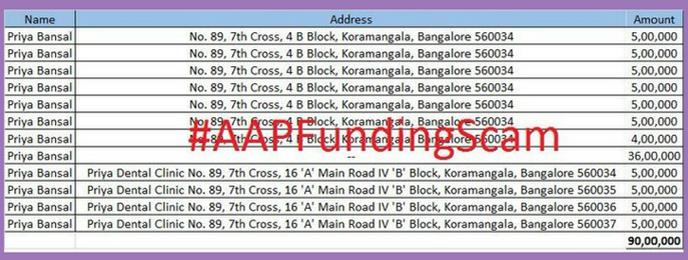

Figure . Details of Rs. 90 lakhs donated by Priya Bansal

Below is another accounting fraud (Figure 2) exposed by Kapil Mishra[27]:

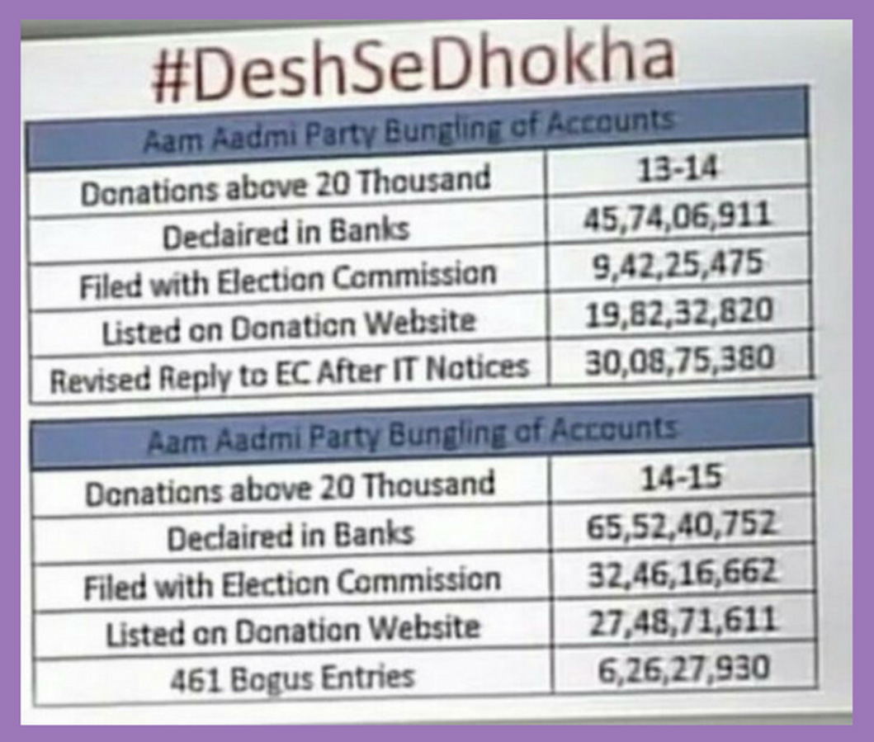

Figure . AAP bungling of accounts

The first row, **Donations above 20 Thousand** refers to the amount of money from donors who paid more than 20,000 rupees each. The second column refers to the Fiscal Year (2013-14 in this case). A second set of numbers are provided for the Fiscal Year 2014-15.

### Kejriwal’s brother-in-law caught

Whenever allegations of financial impropriety were raised against AAP, the cacophony of leaders and cheer leading media houses would sing in chorus that Kejriwal is personally honest. But even this was short lived. His brother-in-law Surender Kumar Bansal got caught for doing fake Public Works Department (PWD) works. In the second week of May 2017, when allegations started pouring in, he met with a heart attack and passed away. A few days after his death, the Anti-Corruption Bureau registered a probe on the corruption and illegalities in the PWD contracts awarded to Kejriwal’s brother-in-law Bansal.

The man who came to power by riding on a wave of anger against rampant corruption and nepotism of Congress government, soon made his own brother-in-law a PWD contractor! Many engineers came on TV and claimed that bills of up to Rs.10 crores were sanctioned illegally to Bansal’s firm by arm-twisting them. The Aam Aadmi Party (AAP) and Kejriwal totally hoodwinked and cheated the people of Delhi’s dreams of a corruption and nepotism-free government.

# Lies of Kejriwal

If Kejriwal’s nose grew like that of Pinocchio’s every time he told a lie, it would rival the tail of Hanuman! The Terminological inexactitudes of Kejriwal are numerous, a few of which are listed below:

After forming AAP, Kejriwal started lying through radio advertisements. He introduced himself as an Income Tax Commissioner, while in reality he had left the service prematurely, as a Joint Commissioner. The Joint Commissioner post is less that of a Commissioner. It is almost as if lying came naturally to him. A pliant media looked the other way when some of his lies were caught in the early days. No one dug into his service records which were very poor. As an IRS officer, he had nothing to show. He never fought against corruption in the department, which is one of the most corrupt. He never conducted a raid or issued notice against a tax evader. While in service, he hardly worked for five years and for seven years, he was on leave. He never left Delhi, even though the rules are clear about no one being allowed to continue in the same place for more than three years in one area. The kind shadow of Sonia Gandhi was always on him to ensure he remained in Delhi. A media creation, funded covertly by Congress to be its B-Team[28], this less than mediocre IRS officer managed to occupy the post of Chief Minister of Delhi! That he was a graduate of the prestigious Indian Institute of Technology made him a darling of the middle class; his initial moves to use auto rickshaws to campaign stuck a chord with the lower middle class and slums and his promise to tackle Electricity and Water Bills (to some extent he did curb these) really endeared him to the masses.

In the early days, whenever he was caught, he would pretend as if he was ignorant of the rules. When some journalists asked about the allegations of funding pattern of his NGOs, he would make a dramatic face and thunder: “Let Government probe and give us double punishment.” That satisfied the pliant media and to some extent, the masses too.

A large measure of Kejriwal’s success was due to the disillusionment of the voters with both the BJP and the Congress, especially in Delhi. That an honest IRS officer, who oozed sincerity, gave up his cushy job to work for the Aam Aadmi, gave hope to the long suffering residents of Delhi.

### Brouhaha over the CWG Scam report

Sometime in the middle of 2010, Kejriwal brandished a document about 370 pages thick, in Jantar Mantar meetings and claimed it as **complete proof** against the then Chief Minister Sheila Dixit’s role in the Commonwealth Games (CWG) scam. Later, when he became the CM, he was confronted by the leader of Opposition, Dr. Harsh Vardhan on not taking any action in this regard. In a surprising U-Turn, Kejriwal demanded the BJP leader to provide proof against Sheila Dikshit! The 370 page dossier that he had flashed in public was just a compilation of newspaper reports! How could a young leader lie like this?

### Saying something and doing the opposite…

Before forming the Aam Aadmi Party, Kejriwal said that he was 100% sure he was not going to join politics. But he did. When AAP was getting ready to contest the elections, he promised that he will not form a coalition with either the Congress or the BJP. He even swore this[29] by putting his hand on the heads of his kids!

To impress voters, he said many times that he will not take any government bungalow when in power. And when he eventually did move to a palatial bungalow as the CM, he gave a lame excuse. There is more! After resigning from Chief Minister’s post for the first time, he did not vacate his official residence. He lied that he had no home to go to! But his election affidavit showed that he owned a house in Gurugram.

### Media parroted Kejriwal’s lies

Kejriwal resorted to trumpery[30], faux sincerity and Newspeak to appear honest. He would pretend innocence and perjure his way out of any situation. Blessed with a smooth tongue, he gave honesty certificates to all and sundry and fooled the Delhi public. Media had a big role in playing up Kejriwal. Without doing even basic fact checking, some media personalities would parrot his statements. This was a classic case of swallow and vomit kind of journalism. Rajdeep Sardesai, his wife Sagarika Ghose and Barkha Dutt and initially Arnab Goswami were his cheer leaders. They portrayed Arvind Kejriwal as a messiah of the Nation. Actually they were building up a relative unknown entity with a pleasant demeanor as a checkmate to Narendra Modi as Congress’s fortunes were sinking. Though they had eternal hope in Sonia Gandhi’s son, for the time being they became public relation managers of Kejriwal.

### Avoided attacking Tata

Even when making allegations Kejriwal was selective. Take the classic case of Niira Radia tapes; In his early years as an activist, he would often mention Niira Radia tapes and would highlight attention to Mukesh Ambani’s link with the controversial lobbyist. He would carefully avoid mentioning anything about Radia’s link with Ratan Tata. Arvind Kejriwal never uttered a word against Ratan Tata, even though Tata Power was a major supplier of electricity in Delhi. Even when he was attacking Private companies supplying electricity to Delhi, he never attacked Tata Power, presumably because he was a Tata employee before joining the IRS.

His avoiding mention of Tata could also be due to getting sizable donations from Tata Group’s companies in his NGO days. Copy of an email exists, in which Kejriwal is seen writing to his colleagues on December 22, 2008 about seeking Rs.50 lakhs donation from Tata. The file is titled as ‘Ratan Tata’ and the donations are for Kejriwal headed NGO – Parivartan – for conducting RTI Awards in 2009.

### Frivolous lawsuits

One of the first things that Kejriwal did as a first time Chief Minister was to register a case against Mukesh Ambani and the then Petroleum Minister Veerappa Moily over the K G Basin scam. Being a Delhi Chief Minister, this was totally out of the purview of Kejriwal and yet knowingly he registered a case. How can a Delhi Chief Minister register a case against Union Petroleum Minister and a Union Cabinet decision? He knew well that the case will not stand in front of law and will be quashed by Court. And that is exactly what happened when Reliance approached the Court and got the case quashed. Due to the advertisement largesse that was coming their way perhaps, the media kept quiet.

As Delhi Chief Minister, Kejriwal had a thousand reasons to file a lawsuit against Anil Ambani for illegalities in power supply in Delhi. But he did not. Why? Obviously, after getting power, he allegedly made a deal with Anil Ambani. Kejriwal always spoke out against two corporates – Mukesh Ambani and Gautam Adani, who had no business with the Delhi Government.

He never uttered a word against Naveen Jindal, who is the second largest beneficiary in the Coal Scam[31]. The reason is simple – Jindal was one of his main financiers. Look at the irony - the AAP, a party formed against anti-corruption was covertly funded by one of the major beneficiaries of Coal Scam! That the people of Delhi got taken for a ride by Kejriwal and the Aam Aadmi Party would be an understatement!

### Selective mud slinging

In the early days, in many press conferences, Kejriwal would mention Niira Radia tapes and her links with Mukesh Ambani. But he never mentioned any journalist caught in the Niira Radia tapes. In one of the anti-corruption meetings, Barkha Dutt was shooed away by the public in April 2010. Arvind Kejriwal gave legitimacy to Dutt by giving her the so-called “exclusive interviews” as his star was on the rise. Niira Radia tapes tell us that Barkha Dutt was part and parcel of UPA’s major deals including the formation of the Cabinet. The lady, who was caught for lobbying for one of the most corrupt Ministers, Andimuthu Raja, was entertained by Arvind Kejriwal. The man made a political fortune riding the anti-corruption wave on the shoulders of Anna Hazare.

Another was Rajdeep Sardesai, who built a palatial home in Delhi worth more than Rs.50 crores during UPA regime[32], was Kejriwal’s Chief Media Advisor. Even Niira Radia’s main advisor, journalist M K Venu, who was closely involved in Mukesh Ambani’s group’s lobbying activity became AAP Government’s nominee in Government colleges. Venu subsequently refused the offer[33]. These things are mentioned to show that Kejriwal has a very selective interpretation of ethics.

The election manifesto of Kejriwal had some utopian dreams. It claimed that Delhi will be made to be like London, with 15 lakh Closed Circuit Televisions (CCTVs), and the entire city would be Wi-Fi enabled! No media house did fact checking to see how he was going to fund all this. Neither did they question his Jan Lokpal Bill tall tales.

### Give Ads, buy their silence!

No one questioned him when he formed the Delhi Cabinet without a lady Minister. Delhi’s Left-Liberal women activists did not utter a word against this decision. All his women candidates became MLAs but he couldn’t find room for even one in his Cabinet! Perhaps to thwart inconvenient questions from the media, Kejriwal was pumping huge advertisements to media houses. Hundreds of crores of rupees were disbursed to the media as advertisements to buy their silence!

Delhi Government’s advertisements were for the most part untruths. For instance, Mohalla Clinics were termed as being World Class! Foreign newspapers and their correspondents were paid heavily to parrot this lie. Nobody questioned Arvind Kejriwal for going to Bangalore for annual rejuvenation treatments for weeks, while Delhi has these so called “World Class” clinics and hospitals! That is the power of the advertisements disbursed by the Delhi Government of Aam Aadmi Party. Every year, more than 200 people die in the streets during the harsh winter. No one questioned this, while the AAP Government was squandering money on newspapers ads for floating lies about their World Class health care system!

### State Unit leader falls to his death

The cruel drama orchestrated by Kejriwal and AAP leaders led to the tragic death of party’s Rajasthan unit leader Gajendra Singh in April 2015. Gajendra Singh was a party worker and a small scale businessman[34] who landed in AAP’s Jantar Mantar rally on the farmers’ issue. He was portrayed as a farmer and the guy was “persuaded” to do some suicide drama by climbing a tree when Kejriwal was about to speak. The script was that he would come down after the assurances given by Kejriwal, having changed his mind. But during the ensuing drama, he lost his balance and the rope hooked on his neck and he died on the spot. Instead of saving him, Kejriwal and gang continued their speech and portrayed his foiled drama as a farmer’s suicide against the Central Government’s policies.

Media went berserk on hearing about a farmer’s suicide at Jantar Mantar. Within hours, people from Rajasthan identified him and revealed the truth that he was not a farmer but a small time trader and politician who had recently shifted from Congress to AAP. Delhi Police had some doubts on the roles of Kumar Vishwas and Ashutosh in bringing him and playing out this failed drama. This was an unpardonable incident and something that Arvind Kejriwal will have to live with, for the rest of his life. This was publicity mongering at its worst.

When Gajendra Singh’s young daughter questioned Ashutosh’s conduct, he simply cried on Live TV[35] and avoided answering the question. Every Aam Aadmi Party leader associated with this cruel drama will pay a price. Law of Karma will catch up with them for this cruelty.

What was disturbing about this episode was that despite knowing the facts, many editors and journalists continued to describe Gajendra Singh as a farmer. That most of the media in India is left leaning or left sympathetic is known. Due to their ideological baggage and burning hatred for Modi, they continued to portray the incident as a “farmer committing suicide in protest against Modi’s anti-farmer policies”. For many of them, the new reality of a single majority party, that can act quickly and decisively is anathema. Access to the corridors of power has been severely restricted under Modi. Vital information that they could glean from talking to Babus has now almost completely dried up, which in turn has led to them having to live within their paycheck.

### Kick away the ladder

Whenever Anna Hazare criticized him, Kejriwal would keep silent or even make a dramatic statement such as “Whatever Anna says, he will be in my heart...” But the fact was that Kejriwal mercilessly kicked out his Guru, Anna Hazare when he started reaping political harvest from the IAC movement.

Same was the case with his seniors Prashant Bhushan and Yogendra Yadav. Prashant Bhushan was Arvind Kejriwal and his gang’s supporter with all kinds of help, including financial. But when he got an absolute majority in the Delhi Assembly elections by winning 67 out of 70 seats, the first thing he did was to terminate Prashant Bhushan and Yogendra Yadav from the party. Most people associated AAP with the triumvirate of Bhushan, Yadav and Kejriwal. Prashant Bhushan and Yogendra Yadav were physically thrown out from the Aam Aadmi Party, of which they were founders! Such cruelty is unheard of in politics. Kejriwal kicked away at least two significant ladders on this way up the political pyramid. One could have predicted that the fall would be hard and swift. Was it? Read on…

### What goes up…

But history and Karma are not merciful. The man who kicked out his Gurus mercilessly is now getting a taste of his own medicine from his once-most-trusted disciple Kapil Mishra, his ex-Cabinet colleague. Almost every day, Kapil Mishra is attacking his Guru Arvind Kejriwal in the same tone and tenor. He has brought out many hawala deals and corruption allegations against Kejriwal, who has not yet answered even one of his allegations. In India, no expelled Cabinet Minister has raised such kind of allegations against a Chief Minister. Kapil Mishra has demolished the entire image of Kejriwal, with his daily dose of expose. The cartoon in Figure 3 says it all! One interesting trait of Kejriwal amidst his tumultuous terms as the CM – he keeps talking about going to see movies!

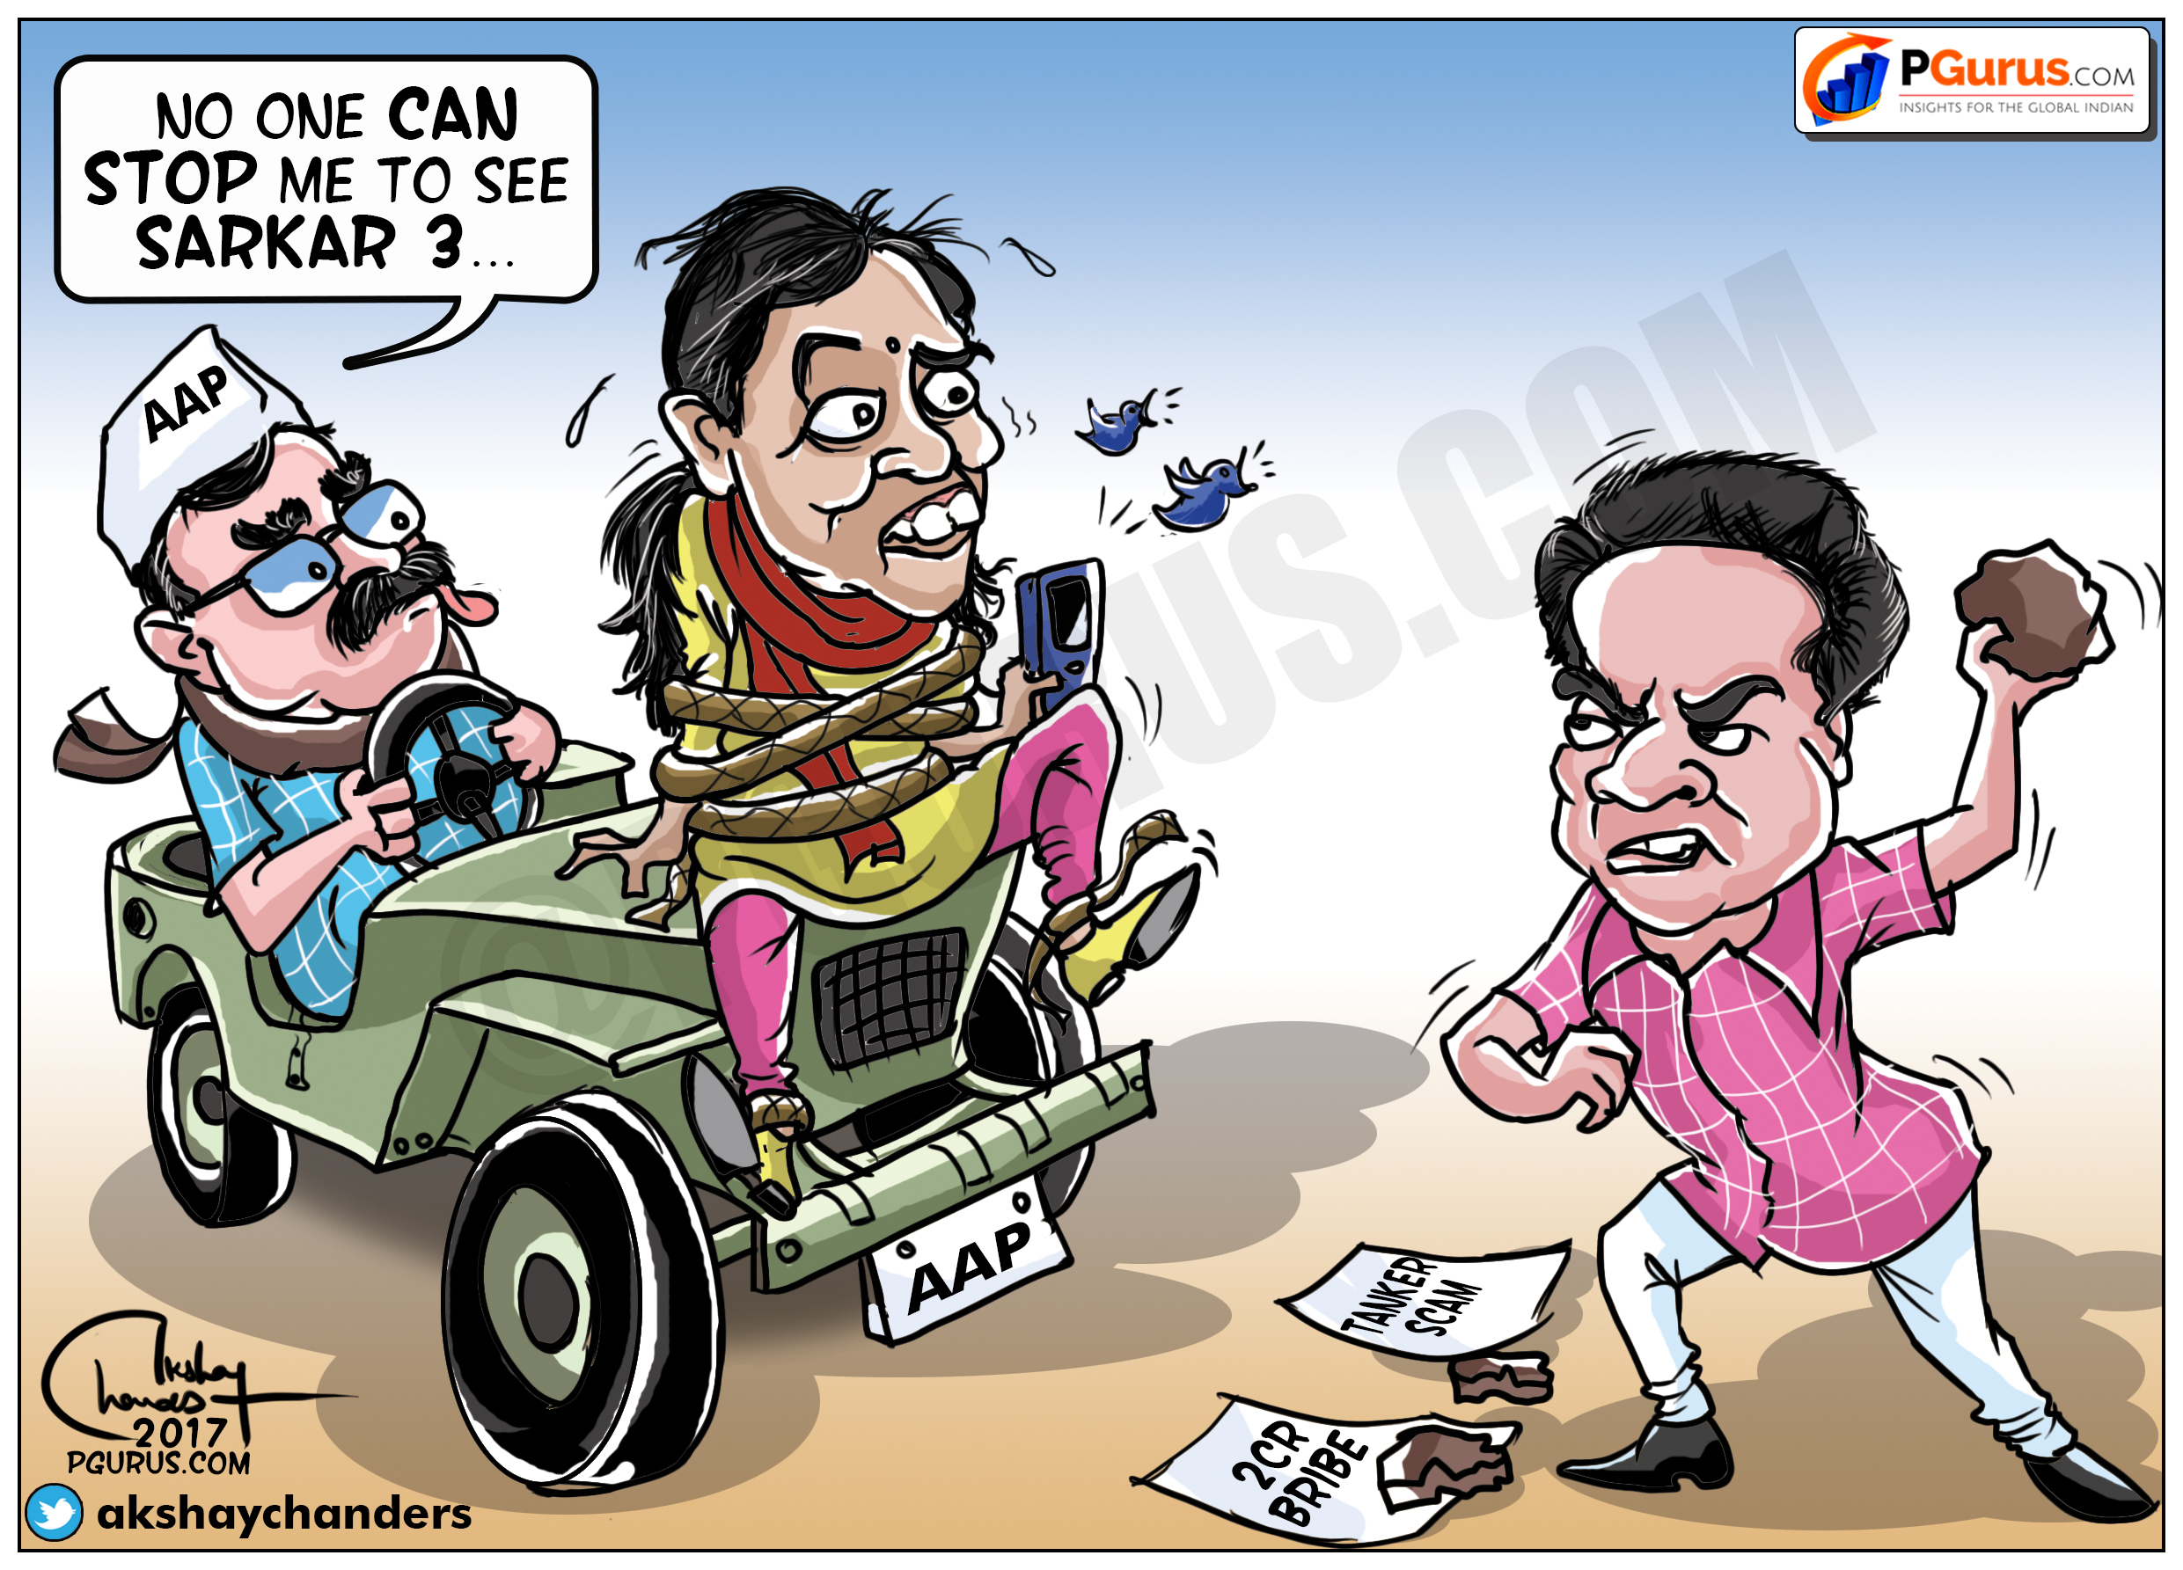

Figure . Kapil Mishra lays bare Kejriwal's corruption

# Role of media in promoting Arvind Kejriwal

Arvind Kejriwal was a media creation, selectively highlighting one individual and ignoring many others who actually fought against corruption in India during the Congress regime. When BJP started gaining ground due to the rise in anti-corruption wave in 2011, many pro-Congress, Left, Muslim and Christian journalists found Kejriwal as a checkmate to Narendra Modi. Many journalists caught in Niira Radia tapes for lobbying during Congress regime also joined this bandwagon. Even many Editors were part and parcel of the gang in promoting Aam Aadmi Party and Arvind Kejriwal.

### Kejriwal as PM?!

Several Editors portrayed Arvind Kejriwal as potential Prime Minister material during the 2014 Lok Sabha elections. How they came to this conclusion is a mystery – Kejriwal had only been in office for 49 days and did not have much to show for it. And they were putting him against Narendra Modi, who had a stellar record as the CM of Gujarat for 12 years!

After Kejriwal resigned as Delhi Chief Minister in February 2014 on flimsy grounds, many Left and Congress supporting journalists were working overtime to portray Kejriwal along with Modi in all columns and debates. Many politically blindfolded journalists like Outlook Magazine’s Political Editor Saba Naqvi even tweeted several times on the possibility of Kejriwal defeating Modi in Varanasi constituency! Creating a Reality Distortion Field was thought to be Steve Jobs’s forte but Indian journalists were taking this art to a whole new level!

### Yogendra Yadav as Haryana CM?

Rajdeep Sardesai and wife Sagarika Ghose went further. The duo also airdropped their friend Yogendra Yadav as potential future Chief Minister of Haryana. In late 2013/ early 2014, Sagarika Ghose even conducted an “exclusive” interview[36]; it would be more appropriate to call it an “arranged chat” with Yogendra Yadav. As they walked on farm fields, Sagarika painted a glowing picture of Yogendra Yadav and strongly suggested him as a future Chief Minister of Haryana. Was this another instance of Paid journalism?

But the wise voter of India saw through this ruse. Yogendra Yadav came in fifth place in the Gurgaon Lok Sabha constituency, losing even his deposit. Rajdeep, Sagarika and Yogendra are part and parcel of “greased” election surveys that is intended to sway the undecided voter, for the past 20 years.

### Varanasi Lok Sabha election

Was it hubris that made Kejriwal contest the Varanasi Lok Sabha election? Or was it a covert attempt by Congress to try and tie down Modi to his constituency, with support from friendly media? The media certainly did its part - every Left and Congress leaning journalist reported dire happenings in the constituency, somehow trying to connect it to Narendra Modi. Fake news and malicious reporting was done with gay abandon, ignoring the facts on the ground. How the media failed to detect the Modi wave beggars belief.

### Caught in the act

India Today Group’s Aaj Tak channel Editor Punya Prasun Bajpai was caught on video[37] for his off-the-record discussion with Kejriwal equating him to the revolutionary Bhagat Singh. A photo of Bhagat Singh was placed strategically to give the message that the AAP chief had the stature of the legendary Bhagat Singh. This episode illustrates how media can create an image, as well as destroy it. Even after being caught red handed many journalists continue to do this, giving sermons along the way. Funny how they forget their own sermons when it is time to practice them!

### AK as Opposition candidate for PM?

Apart from hobnobbing with Editors in creating propaganda and fake news, Kejriwal and Aam Aadmi Party kept a battery of ground level reporters to parrot their agendas. Many facilities from Delhi Government were doled out to hundreds of journalists. Whenever Prime Minister Narendra Modi made any announcements, this coterie’s primary job was to bring Kejriwal’s version and make it look as it he already has a solution for this. All this to raise his stature and project him as being of Prime Minister material. Is this ideological slavery by some or a quid-pro-quo for the services received from Delhi state government?

Many journalists were posted as Members in several committees and bodies of Delhi state government. Some were secretly provided material benefits like high-end mobile phones. There was a joke in the Delhi Secretariat corridors about many AAP friendly journalists using same make of high end Smart Phone worth around Rs.30,000 each from late 2015. The Delhi Government had purchased in bulk quantity, a single brand of high end smart phones for the use of senior officials. The rumor doing the rounds was that around 30 friendly journalists were given smart phones secretly by the Kejriwal Government. This might be the first time in Indian history that the government was doling out such benefits to pliable journalists. Normally phones and iPads were doled out by Corporates. We have seen the list of journalists and officials received from Essar Group[38]. But a Government giving mobile phones secretly to journalists might be the first time!

Whenever Kejriwal and AAP were caught for blatant corruption and money laundering, media houses would keep a stony silence. For instance, take the midnight money transfer of Rs.2 crores by a Sales Tax defaulting company to AAP. This was a clear cut case that came under the Prevention of Corruption Act and Prevention of Money Laundering Act. Instead of reporting the facts, certain media houses and Editors were arguing that these were all Narendra Modi’s attempt to malign their dream leader Kejriwal!

Many media houses did not publish the news of BJP leader Subramanian Swamy’s complaint to Lieutenant Governor[39] for Sanction to Prosecute Chief Minister Arvind Kejriwal and Deputy Chief Minister Manish Sisodia. Not one journalist asked Kejriwal or Sisodia for a response in this Open and Shut case. Such a clear case of corruption was swept under the carpet by media houses due to their proximity to Kejriwal, mainly due to the largesse extended in the form of huge advertisements by the Delhi Government.

### Paid Advertisements lack civility

As of date, there is still no clear record of how much money Delhi Government pumped into media houses as advertisements. Most of the advertisements issued by Delhi Government lacked civility. For instance, there were some ads that ridiculed the Prime Minister! Have we ever heard a state government issuing advertisements ridiculing the Prime Minister of the country? And many such ads were splashed all over the country! Delhi is at best a token state – the CM is a glorified post, with no control over Law and Order of Delhi (that falls under the Home Ministry’s Office). These ads can only be described as crass and cheap – done purely with the intent of self-aggrandizement. No one from the media ever raised any questions in this regard. Some even went to the extent of justifying these advertisements and malicious tweets of Kejriwal and AAP Ministers against Prime Minister Narendra Modi.

### What about the poor voter of Delhi?

That Kejriwal took the people of Delhi for a ride is an understatement. He silenced media by pumping a lot of money through advertisements. AAP was perhaps the first State Government that parroted its “achievements” nationwide, by taking out newspaper ads all over the country. Most were false claims and cheap gimmicks. Many of these were just slurs against the Prime Minister Narendra Modi. Hundreds of crores of taxpayer’s money were wasted for self-promotion, Aam Admi Party’s image building as well to make Kejriwal a larger than life personality. All this meant no money for even the most basic amenities of the city (Figure 4). 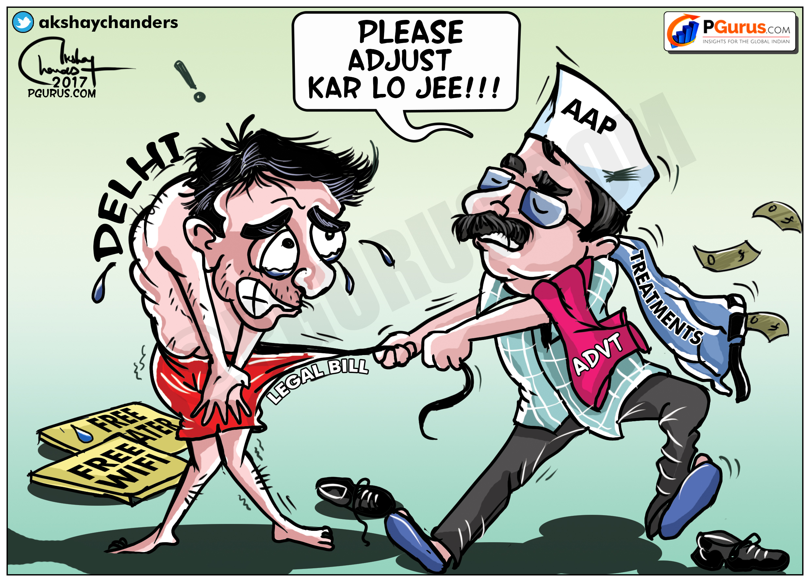

Figure . Nothing left for the city!

While the advertisements proclaimed Delhi’s local clinics to be “World Class”, His Majesty Shri Arvind Kejriwal would run to private hospitals in Bengaluru for even simple treatments. This slew of faux Ad-pumping had to be stopped. His former mentor and a co-founder of AAP, Prashant Bhushan filed a Public Interest Litigation (PIL) on these unscrupulous fake advertisements in the Supreme Court, in which the Court intervened to bring directions on Government advertisements.

### Odd-Even plan for regulating traffic

Remember how most of the journalists praised Kejriwal for his “inspired” plan called Odd-Even for regulating the traffic? It was just another Thuglak like move repeated in Delhi. Nobody questioned it when vehicles were blocked on plying on the roads on particular days. Such was the level of mental slavery exercised by the Editors of Delhi media. Nobody did a critical analysis of this failed programme of Arvind Kejriwal. Did the pollution go down? If so, by how much? And what was the collateral damage?

It gets worse – not only did the media keep silent on the objective of the Odd-Even programme, journalists unabashedly praised the programme. It was a known secret that many a palm was greased for praising Kejriwal and the Delhi Government. All one had to do was put out favorable tweets and posts on Facebook. The payments were made in covert methods through Public Relations (PR) agencies entrusted with building up the image of Kejriwal.

### Fishing in troubled waters

One of the biggest instances of duplicity by Arvind Kejriwal was the way he dealt with the controversies related to the suicide of Hyderabad Central University student Rohit Vemula and chaos unleashed by Left Liberals in Jawahar Lal Nehru University (JNU) and Kanhaiah Kumar episodes.

Kejriwal was among the first of many leaders to air dash to Hyderabad when a controversy erupted when a student committed suicide in the Hyderabad Central University hostel. He belongs to the Other Backward Class (OBC) community and faked his caste certificate as Dalit to get admission. Rohit was suspended from the hostel due to a brawl with Akhil Bharatiya Vidyarthi Parishad (ABVP) students[40]. The video conversation (in Telugu with English sub-titles provided on the side) shows ABVP members confronting Rohit about a banner tearing incident.

Rohit explains that he hates saffron and will tear it wherever and whenever he can. He goes on to say some uncomplimentary things about the treatment meted out to Dalits to which an ABVP member, himself a Dalit rebuts.

In a troubling development Rohit and his Ultra Left Student Union conducted a protest march in the University when Mumbai blast convict Yakub Memon was hanged. What does an Ultra Left Students Union have to do with the terrorist Yakub Memon belonging to the fugitive Dawood Ibrahim gang? Was Pakistan based Dawood gang funding these mischief making student unions across India?

This protest against the hanging of the terrorist was criticized by an ABVP leader through a Facebook post. Rohit and his gang of students beat up the ABVP leader and forced him to delete the Facebook post and made him to post apologies[41]. This happened in the wee hours of the night and the next morning ABVP complained to the college authorities. No action was taken and the ABVP went to complain to the local police station. Action started after the local MP and Union Labor Minister Bandaru Dattatreya intervened on the issue. ABVP approached Courts and at last University took action by suspending Rohit Vemula from the hostel due to the unpardonable hooliganism in the campus. After this incident Rohit was isolated from the student community and he was deranged. But he illegally stayed in the hostel and was found hanging there.

Such a prodigal student’s suicide was portrayed as a big issue by Congress, Left and Modi hating media persons. Student unrest was orchestrated across the country by the opposition parties ignoring the actual reasons of the issue. But the cunning media never blamed the Telangana state government for lathi charge against the protesting students. They only portrayed the incident at the Central Government in Delhi. Arvind Kejriwal even announced cash compensation and jobs for Rohit Vemula’s relatives[42]!

### Unrest in Delhi’s JNU

Within a month of this incident, a similar kind of orchestrated student unrest happened in Delhi’s JNU by an Ultra Left student wing. Media portrayed a student leader Kanhaiah as a star in the making. But here Kejriwal kept quiet, though the place of occurrence was very much in Delhi. The man who air-dashed to Hyderabad did not even visit the JNU campus. The reason was very simple. Arvind Kejriwal’s strategic political ally was West Bengal Chief Minister Mamata Banerjee who hated the JNU student leadership controlled by her arch rival CPM. Kejriwal even denied meeting with the student leader Kanhaiah. Once the Left leaders fixed a meeting of Kanhaiah with Kejriwal. But clever Kejriwal cancelled it saying that Kanhaiah got delayed. And till date he has not given any audience to JNU’s Left gang to avoid incurring Mamata Banerjee’s wrath.

Sly Kejriwal is aware that the Left is a party that has a base in Kerala, Bengal and Tripura but with very few MPs and associating with them would invite the wrath of the Trinamool Congress (TMC) supremo who has around 50 MPs in the Parliament. Even though the Left parties with a handful of votes in Delhi voted for AAP, Kejriwal did not oblige them. Media and Left wing Journalists hushed up this duplicity and always wanted a good relationship with Kejriwal, in the interest of uniting all Modi hating gangs. But Kejriwal knew which side of his bread is buttered and never uttered a word against Mamata Banerjee.

### Modi for India and Kejriwal for Delhi

When Narendra Modi came to power with a thumping majority in May 2014, within weeks, AAP put up posters across Delhi claiming – Modi for India and Kejriwal for Delhi. AAP never explained the logic of this poster and the pliant media, instead of questioning it, just lapped it up.

Delhi media, rolling in the advertisement money from the Delhi Government never questioned Arvind Kejriwal as to why he was spitting bile and vitriol against the Prime Minister. The same media however questioned the language used by AAP rebels such as Kapil Mishra and even advised them to refrain from using such kind of language! Media would quickly portray anyone who questioned Kejriwal or AAP as a Modi or a BJP or a Sangh Parivar agent. They never looked into the merit of the charges or allegations. Many columnists wrote that these were the attempts to malign an “honest person” like Arvind Kejriwal. Singing praises of a benefactor comes easy to some journalists in Delhi.

Media never reported the details of the contracts awarded to Arvind Kejriwal’s cousin late Surender Kumar Bansal. There are around 100 reporters roaming around the Delhi Secretariat and many were aware of the rise of Surender Kumar Bansal and his frequenting with Kejriwal, Manish Sisodia and PWD Minister Satyender Jain. Some crooked reporters were part and parcel of this racket too and were happily getting their pound of flesh. When Cabinet colleague Kapil Mishra started exposing these details, most pretended innocence. In such cases media has a routine word in the dictionary – political vendetta. Senior journalists like Rajdeep Sardesai will give a spin to the debates on corruption in Delhi Government alleged by Kapil Mishra, by asking “Are these allegations due to police vendetta?” or “What is the timing?” But when called presstitutes, they (Indian Media) take umbrage!

### Debacle in Punjab and Goa

Whether it was AAP money or ideological baggage, much of the media was talking up the fortunes of AAP in Punjab and Goa. Many predicted that the party was going to get an absolute majority in Punjab state Assembly elections in March 2017. Some convincingly wrote and predicted that AAP would get a minimum of 80 to 90 seats in the 117 member strong Assembly. These media houses totally ignored the winner Congress under the leadership of Captain Amarinder Singh.

Many in the media predicted a surge for AAP in the Goa Assembly election too, where the party failed to open its account. The wise Indian voter had started seeing through the Teflon coated image of Kejriwal that the media had built up. No matter how hard the media tried, and how much money AAP spent (where did they get all the money?!), in the end the voters of Punjab and Goa booted out AAP.

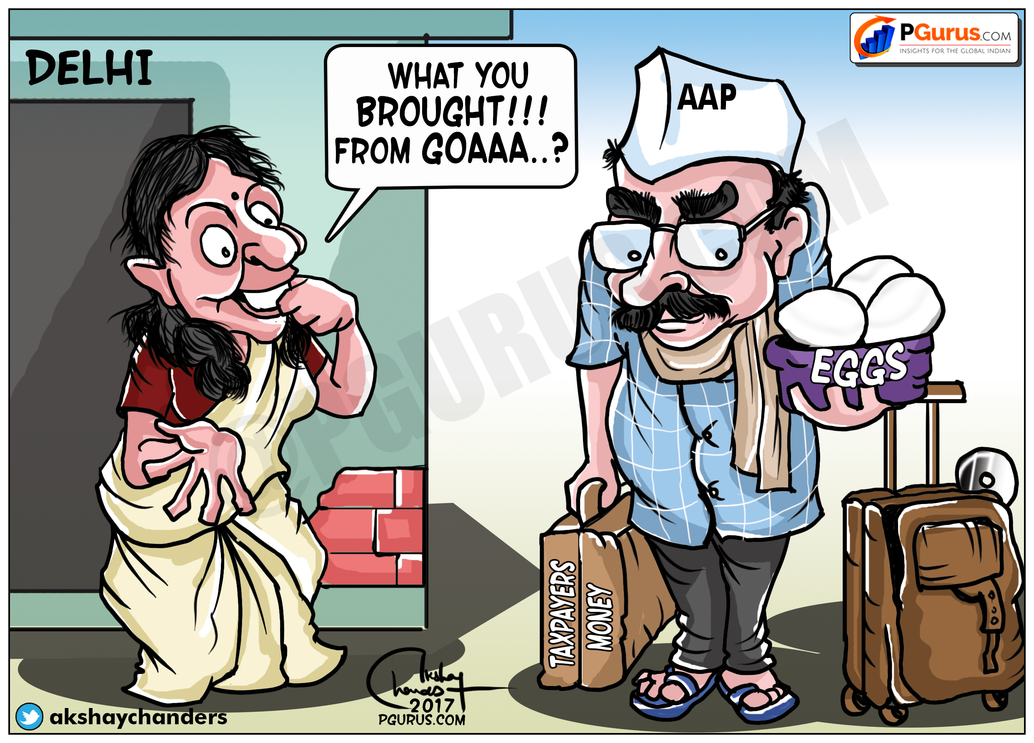

Figure . Zero seats in Goa!

The election results of Punjab and Goa were a slap on the face of AAP as well as the Paid Indian news traders. Before the results came out, AAP even started deciding the portfolios. Some even wrote about the chances of Kejriwal becoming the Chief Minister of Punjab by giving Delhi Chief Minister’s franchise to crony Manish Sisodia. After losing, they started to parrot Kejriwal’s fake theory of expressing doubts on Electronic Voting Machines. When challenged by the Election Commission to test the Electronic Voting Machines and prove inconsistencies, AAP decided to stay away. Another instance of shoot and scoot by Kejriwal! The pliant media did not report this fact either!

These incidents are proof that Arvind Kejriwal was a media creation, and his meteoric rise happened because of the patronage of corrupt Indian media houses.

### Blame the EVM

Arvind Kejriwal’s latest venom spitting was against Electronic Voting Machines (EVMs) after his party lost the election in both Punjab and Goa. Instead of dong a serious introspection as to why people rejected him, Kejriwal started accusing the Electronic Voting Machines (EVM)s. He even claimed he can hack the EVMs and conducted a farce Assembly Session and showed some gimmicks. But when the Election Commissioner challenged him to hack their machines, he ran away and did not show up. Shoot and Scoot is Kejriwal’s Unique Selling Proposition (USP) with the help of pliant media. 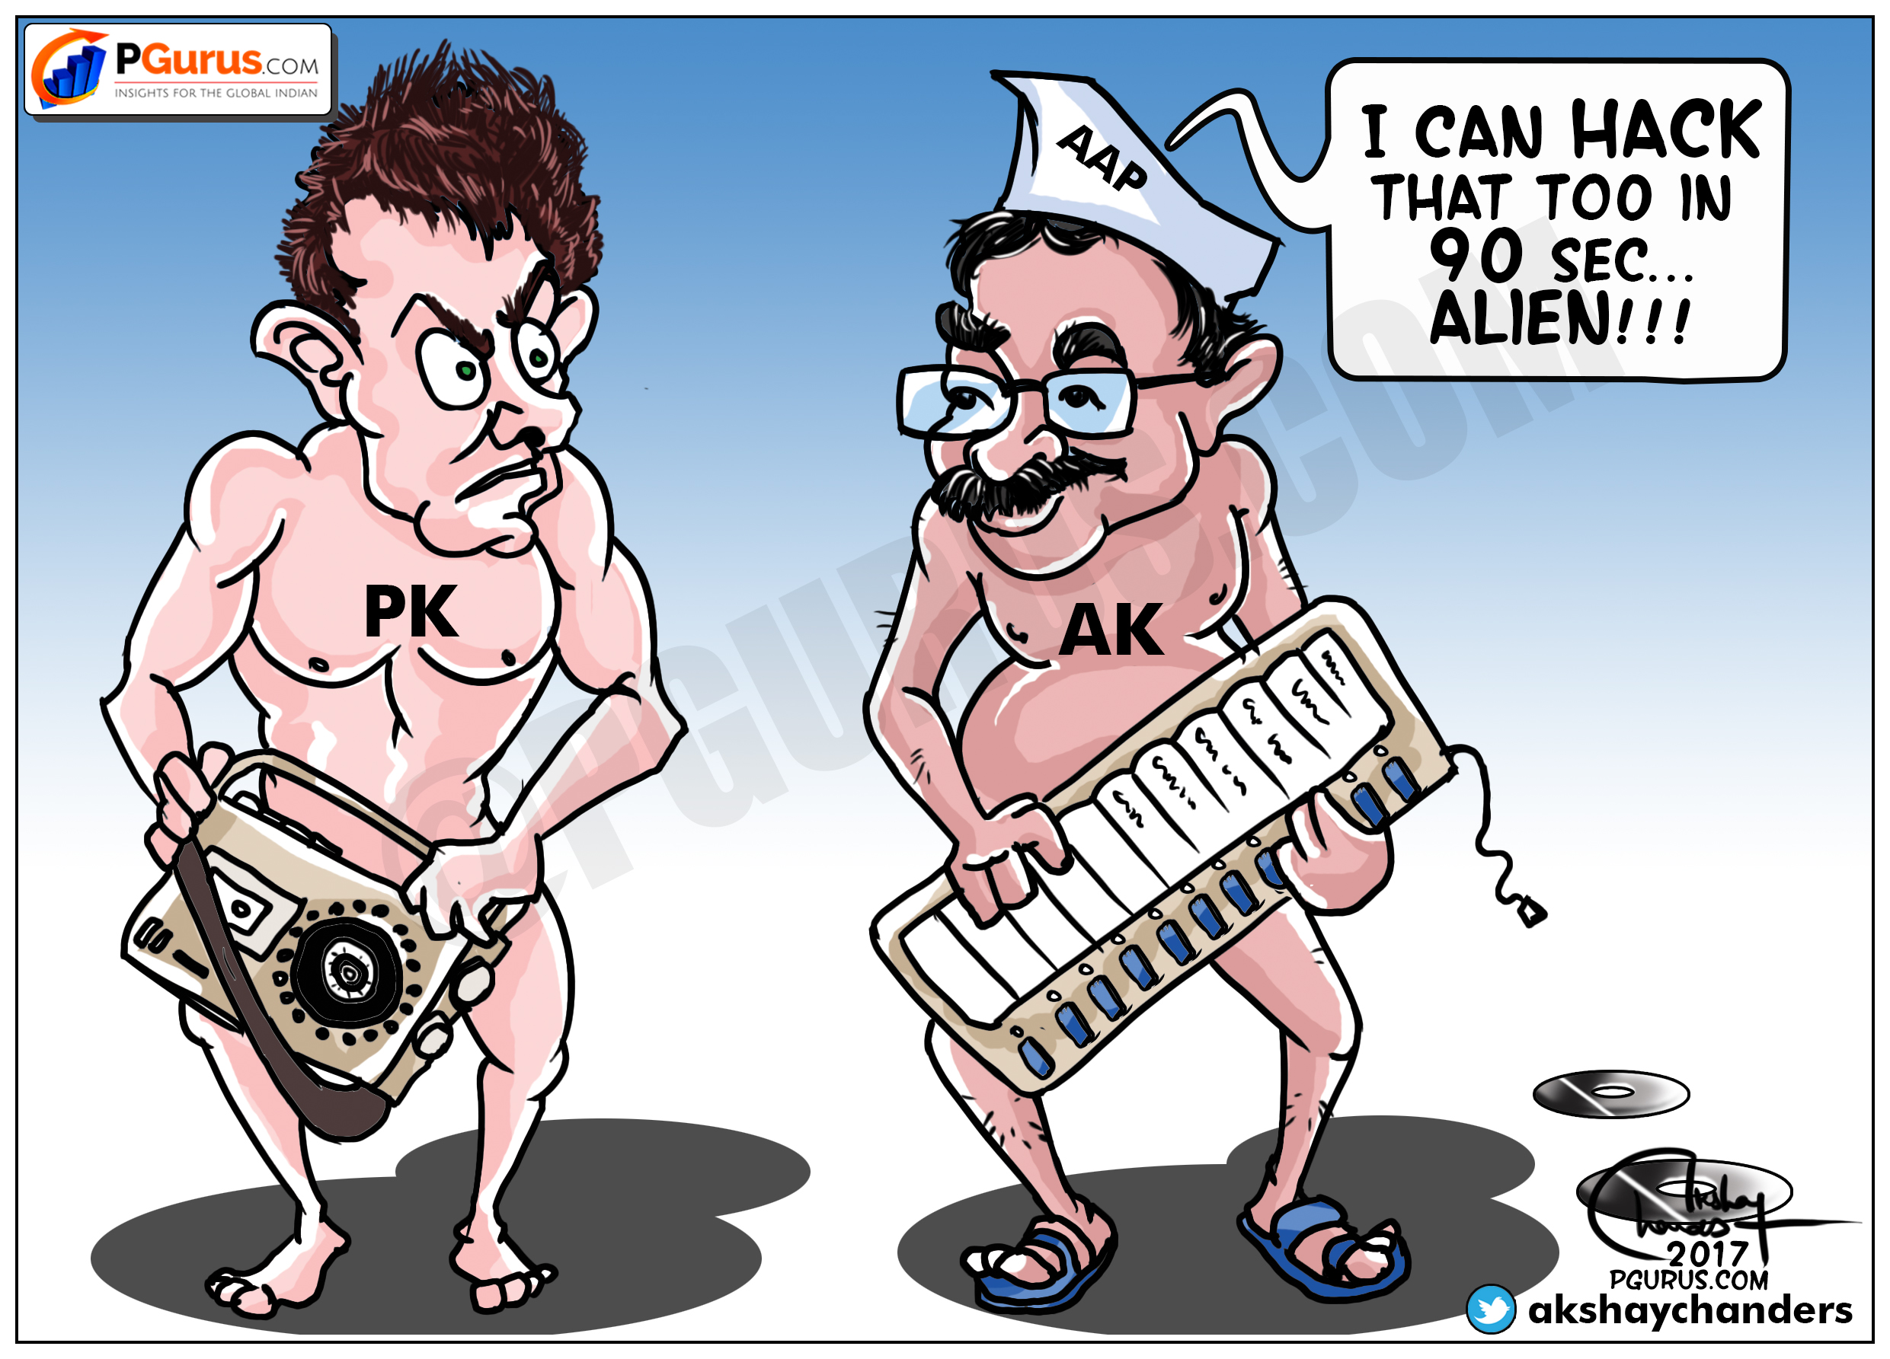

Figure . AK challenging PK!

### Chasing TRPs

Seeing Kejriwal taste success with Modi bashing, Rahul Gandhi started copying Kejriwal’s style of mudslinging. By mid-2015, losing all hope, Rahul also started abusing Modi and started posting silly questions and casting aspersions against Prime Minister Narendra Modi to get attention. Both were desperate for media attention and were trying to outdo each other in disparaging Modi. By 2016, these tirades often became “Breaking News” or front page news items on willing media, who was only too happy to publish anything for a price. The shoot and scoot policy of Kejriwal was just copied by Rahul Gandhi in attacking Modi. The only difference was Kejriwal invents his own style and Rahul was swallowing and vomiting the written notes handed over by the Dirty Tricks Department of Congress. In one such instance, a sharp video camera person caught Rahul Gandhi with his notes[43]!

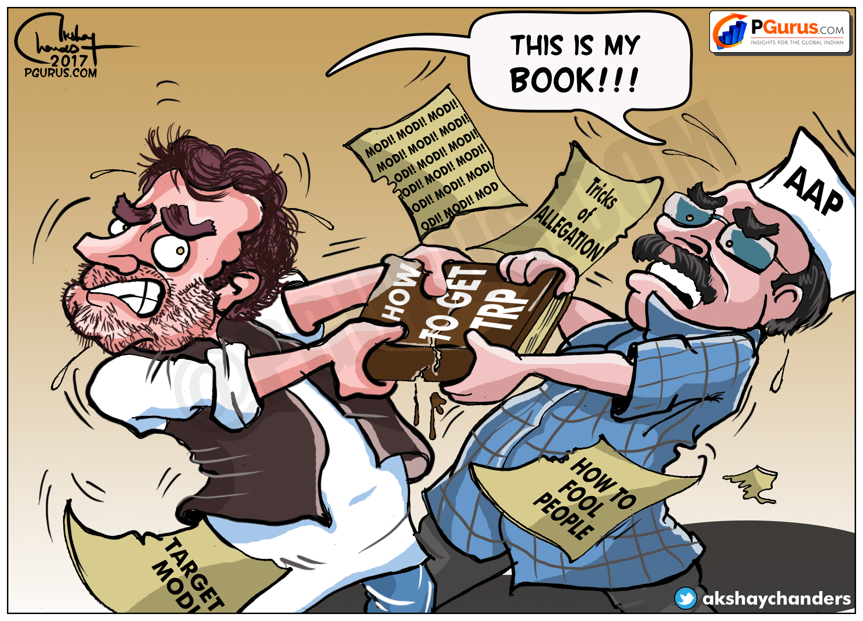

Figure . TRP Magic formula

# Delhi MCD elections

Results to the Uttar Pradesh, Punjab, Goa, Uttarakhand and Manipur were announced on March 20, 2017. Elections to the various municipalities in Delhi were held on the 23rd of April, 2017. After the Punjab and Goa defeats, AAP knew that they were at risk, even in the one city that they held power.

Perhaps in desperation, Kejriwal started making weird statements, telling the people of Delhi that if they voted for BJP, their children will get Dengue[44]! Was this the last straw that broke the camel’s back (Figure 8)? Delhi BJP also had in its ranks Dr. Harsh Vardhan, who is credited with eliminating Polio from India[45]. Going negative against the BJP on health grounds backfired spectacularly against Kejriwal!

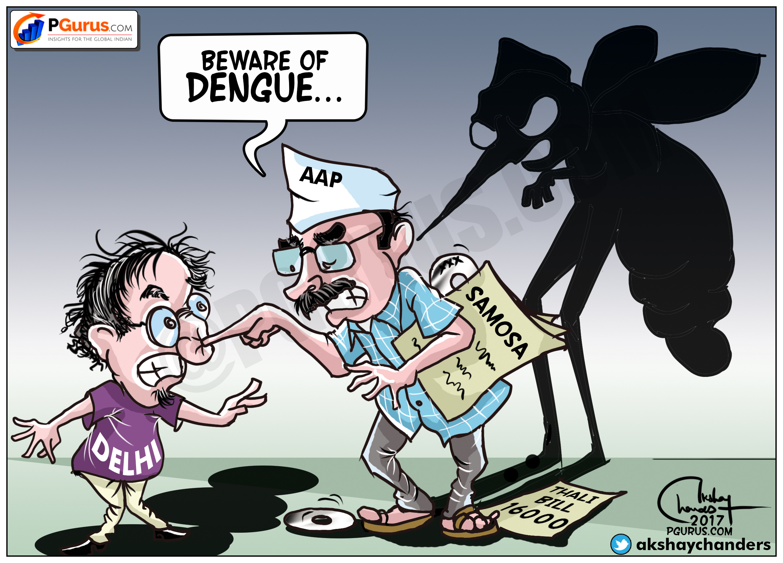

Figure . Dengue threat to the Delhi Public

This and most other cartoons depicted in the book always show a Compact Disc (CD) in the background, a stark reminder of the Sex for Ration Card scandal.

### Aftermath of the MCD elections

When the results of the MCD poll were coming in, it was clear that Kejriwal had lost its magic touch. It was also clear that Congress had decided to stay on their own and cut into AAPs votes, underlining the fact that the Delhi State elections victory of Kejriwal was in a large part, due to Congress cross voting for the AAP, with the sole intention of defeating the BJP.

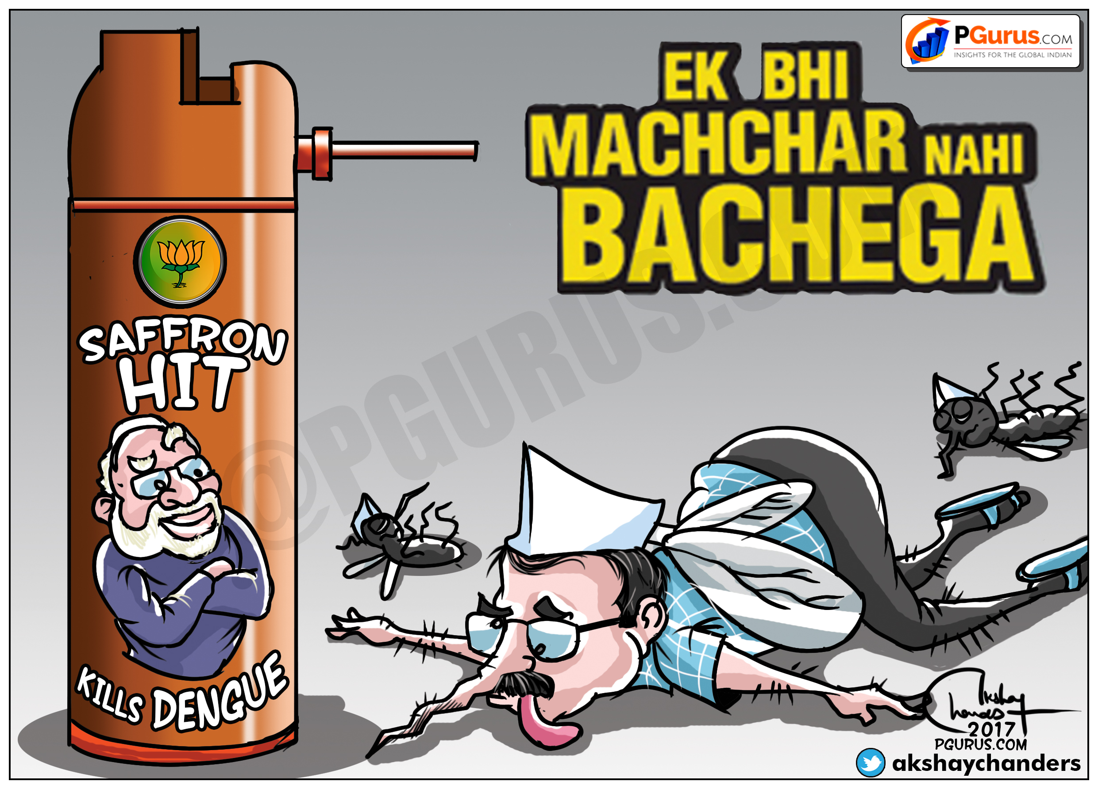

Figure . Modi squashes Kejriwal in MCD elections

Whether the Aam Aadmi Party got together and took stock of the MCD polls or not, the media sure did. It was clear that all was not well within the party. Kumar Vishwas, who had stuck with Kejriwal through thick and thin was thinking of leaving the party. As a compromise, Kumar was persuaded to stay while the Okhla MLA Amanatullah Khan[46] was suspended. This happened on May 7th, 2017.

Arnab Goswami’s new TV channel, Republic TV interviewed Kapil Mishra on the same evening (May 7, 2017) after he was sacked from the party. In a tell-all interview, Kapil Mishra lay bare[47] the shenanigans of AAP and its supremo, Arvind Kejriwal.

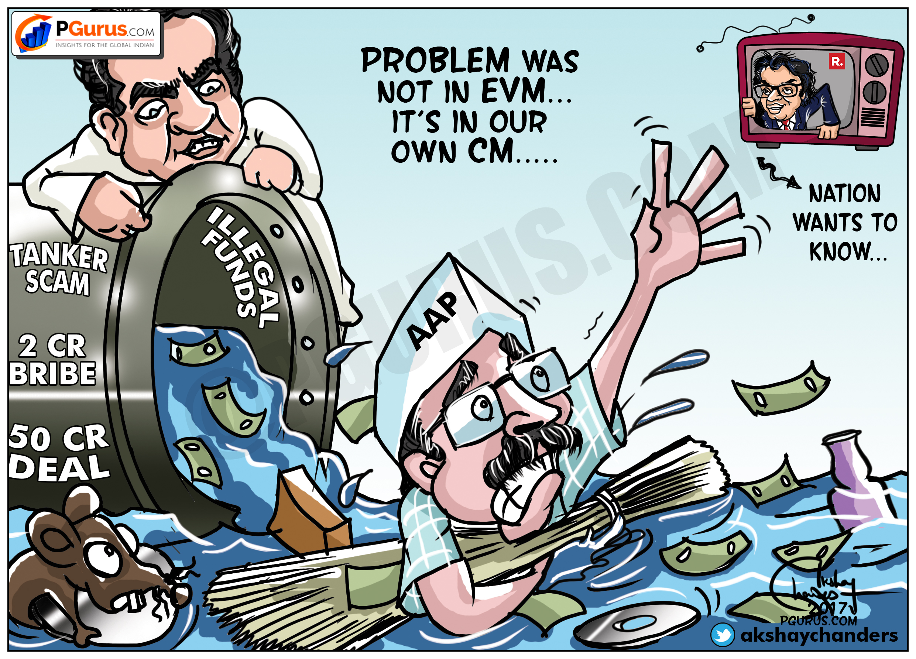

Figure . Washing dirty linen in public

# Kejriwal’s trust deficit

Kejriwal is not averse to being dramatic - In his swearing in as Chief Minister twice, he sang a song[48] from the film Paigham originally sung by Manna De on brotherhood. The lyrics of the beautiful song on brotherhood go as follows:

**insan ka ho insan se bhaichara**

**yahi paigam hamara**

**yahi paigam hamara**

**naye jagat me huya purana**

**unch nich ka kissa**

**sabko mile mehnat ke**

**mutabik apna apna hissa**

**sabke liye sukh ka barabar ho bantwara**

**yahi paigam hamara**

**yahi paigam hamara**

**harek mahal se kaho ke**

**jhopdiyo me diye jalaye**

**chhoto aur bado me ab**

**koi phrak na rah jaye**

**is dharti par ho pyar ka**

**ghar ghar ujiyara**

**yahi paigam hamara**

**yahi paigam hamara**

**insan ka ho insan se bhaichara**

**yahi paigam hamara**

**yahi paigam hamara**

### I, me and myself

Kejriwal never intended for AAP to be a democratic party. It was all about him and his advancement. That the above song was merely lip service is evident from the way he has treated his seniors Prashant Bhushan and Yogendra Yadav. Not only did he keep them away from his Cabinet, after the stunning success in 2015, among the first things he did was to throw them out of the party. Was this his definition of “brotherhood”? Would he have attained this amount of success without their help?

What about his display of brotherhood in brutally throwing out the opposition leader Vijender Gupta from the Delhi Assembly **several** times? Does he listen to the dissenting views in his party? What happened to his Cabinet colleague Kapil Mishra? After questioning Kejriwal, Kapil Mishra was brutally manhandled in the Assembly.

By doing something unusual, such as singing a movie song during the swearing in ceremony, was Kejriwal trying to fool the country? The man who preached and sang about brotherhood was acting like a mafia don when he became the Chief Minister in 2015 with a brute majority. Instead of doing good governance with this huge mandate, he was engaged in cultivating dirty coterie culture and bulldozing dissenting voices in the party.

The media, satisfied with advertisement largesse from the AAP, kept quiet. Many in the media who dared to write or speak against Arvind Kejriwal were sidelined by the media owners – they knew which side of their bread was buttered! Even some Bureau Chiefs of major media organizations were forced to leave for tweeting against Kejriwal. It was as if the journalists were being warned, “Write against Kejriwal at your own peril!”

Soon after coming to power, Kejriwal urged people to record on their mobile phones if any official demands bribe. But sting operations came back to haunt him as people realized that AAP was just as bad as the others. One of his Ministers was caught for a sexual escapade with a lady, when she approached for a Ration Card allotment. Some people started recording conversations with Kejriwal, in which he was caught abusing his mentor Prashant Bhushan and Yogendra Yadav.

Sensing the danger of people recording his rants on mobile phones, Kejriwal banned people from bringing in their mobile phones for meeting with him. But the damage was done.

### Kumar Vishwas – in, looking out?

After the removal of Prashant Bhushan and Yogendra Yadav, Arvind Kejriwal and his coterie were working hard to sideline Kumar Vishwas. The reason was simple. Kumar Vishwas’s popularity gave Kejriwal nightmares. In every party decision that was taken after Kejriwal became Chief Minister, Vishwas was sidelined. All those close to Vishwas were shunned from party posts and in the government. But Kumar Vishwas, like Kapil Mishra was an expert in giving it back to Kejriwal and his coterie in the same token. Their rivalries were always out in the open. Whenever Vishwas raised a red flag, Kejriwal and gang would term him as BJP agent. This is an ongoing fight with an uneasy truce in place. Kejriwal’s deputy Manish Sisodia was instrumental in making Kejriwal and Vishwas bury the hatchet, albeit temporarily.

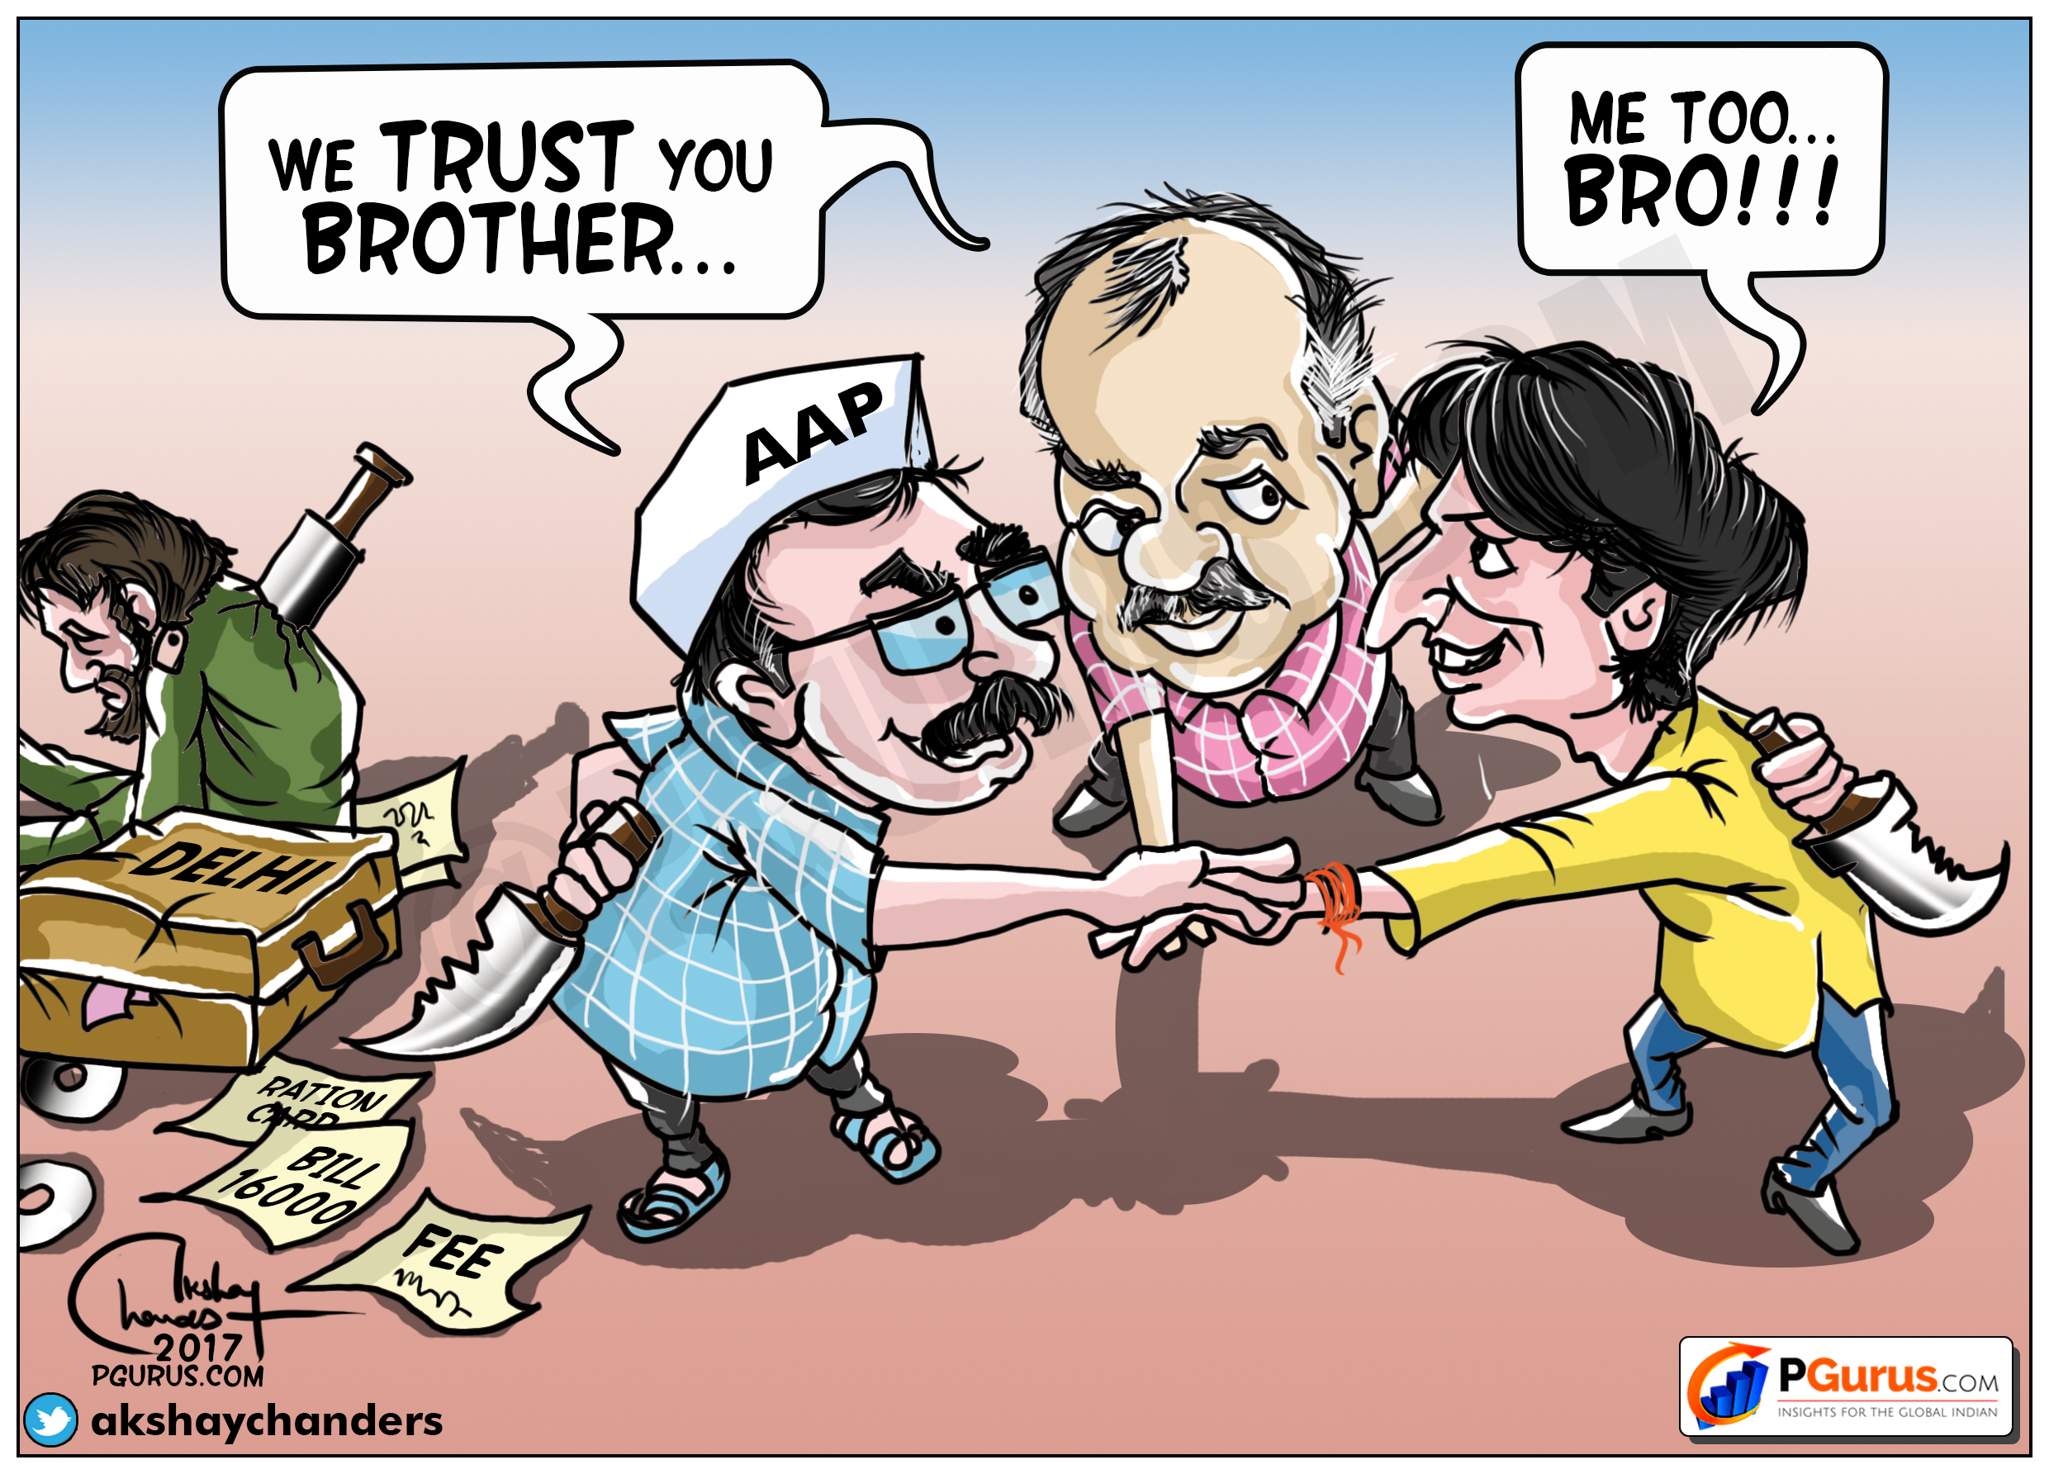

Figure . A temporary truce

It is not easy for Kejriwal to kick out Vishwas because he knows where the bodies are buried (metaphorically speaking!) as he has been there from the beginning and he is not as sophisticated and polished as Prashant Bhushan and Yogendra Yadav. Whenever Kejriwal and team turn against him, Vishwas and gang also drop hints to expose some old dirt or the other. Then for a few months there will be a state of détente. It is a known secret that Vishwas tried to break AAP during the rebellion started by Cabinet colleague Kapil Mishra. Vishwas was a part and parcel of the early controversial fund collection of AAP and was involved in many foreign trips and fund collection drives.

### Saga of the 21 MLAs

The massive mandate of the Delhi people went to the head of Arvind Kejriwal. He started ignoring the laws and even the Constitution. His biggest folly was in illegally appointing 21 AAP MLAs as Parliamentary Secretaries. This gross violation of the law was ignored by the media which as usual kept quiet. But the AAP supremo tasted heat when a young advocate Prashant Patel challenged this appointment. When he filed this complaint, all media houses ignored the petition of this young lawyer. What was worse was that some columnists and veteran journalists wrote articles praising the creation of this illegal 21 posts to exhaust the pubic exchequer! Many even questioned the complaint of the young lawyer demanding the cancellation of the membership of the 21 AAP MLAs under the Office of Profit Act.

Now Prashant Patel has been proven right. The Election Commission is expected to pronounce its verdict soon. Patel’s lone battle is nearing victory and this case is going to have huge repercussions in AAP when his MLAs will lose their posts, leading to by-elections in Delhi. We have seen people’s anger in Municipal elections. In an Assembly by-election AAP candidate came a distant third, losing his deposit. This seat became vacant when an arrogant AAP MLA resigned and went to contest in Punjab, where the party’s hype and dreams collapsed in March 2017. The wrath of people is going fall on Arvind Kejriwal on this illegal decision.

### Plagiarism charges

**Arvind Kejriwal is now facing charges of plagiarism. Activist and former colleague Ajay Pal Nagar has moved a local court in January 2014 for stealing his thesis**[49]**. Ajay Pal Nagar alleged in a local court that Kejriwal’s book Swaraj copied the contents of his book titled Bharatiya Raj Vyawastha. Nagar claimed that he had presented the book to Kejriwal in March, 2012 and he was appalled to see its contents being copied in ‘Swaraj’ that was published in July 2012. A case has been filed before the District Judicial Magistrate of Noida in January 2014.**

Ajay Pal Nagar said Kejriwal plagiarized it intentionally. “Kejriwal has illegally published my book in his own name and has added some Government documents to mislead the people,” the complainant said.

The activist, in his complaint before the court, alleged that 80 per cent content of Swaraj has been copied from his book which is a clear violation of the Copyright Act. Nagar said that he wrote the book Bharatiya Raj Vyawastha in the year 2011 and the book was published in February 2012. Later, he sent a copy of the book to Kejriwal on March 26. In June 2012, when Swaraj was released under the name of Arvind Kejriwal, Nagar found that Kejriwal has taken most parts of his book without his consent to do so. He found that many pages, paragraphs and lines of Swaraj were copied verbatim from his book!

Earlier the author had lodged a complaint in Badalpur police station in December 2012 but no action was initiated against Kejriwal and the matter was almost closed. Nagar then went to the Chief District Magistrate Court of Noida where his application under Section 156 (3) of CrPc (Criminal Procedure Code) was taken up by the Magistrate.

“I wrote the book, Bharatiya Raj Vyawastha, with 10 years’ experience of my social life. I met eminent lawyers, socialists, constitutional experts and many more before writing the book. As I was impressed with Arvind Kejriwal and his team during Anna movement, I sent a copy of my book to Kejriwal but he took unfair advantage of it. I have moved the court for action against him for exclusive theft and a case under Section 200 of CrPc has been registered against Kejriwal. The court could serve notice to him. If required I will move the upper courts for justice,” said Nagar to media after filing the case. Till date Arvind Kejriwal has not yet uttered a word about this and the case is still in trial stage.

### Covering all the bases

Kejriwal would tell anything to connect with the audience – Not that other politicians don’t but he took this to a whole new level. Vande Mataram, Bharat Mata Ki Jai and Inquilab Zindabad would be used liberally to make the audience feel that he was one of them. He was trying to attract the Right Wing votes, the common masses that started coming to his rallies and at the same time do a monkey balancing act of keeping his Left and Ultra Left ideologues happy. He would also wear the Islamist leaders’ skull cap also to tap the Muslim votes. While hobnobbing with Ultra Lefts, Kejriwal always maintained good relations and a strategic alliance with Trinamool Congress supremo Mamata Banerjee. He always weighed Mamata Banerjee for buttering Bengali votes in Delhi. In crucial decisions, Kejriwal has always gone with TMC and dumped the Left. He never annoyed her (the TMC Chief) and even avoided entering into the JNU protests engineered by the Left Wing. Full marks to Kejriwal for keeping opposing forces happy and yet extracting full political mileage out of it.

# Where does AAP go from here?

The Indian voter is wise but at the same time he/ she is emotional too. Which of the feelings come to the fore when he/ she is casting the vote decides an election. It is entirely possible that Kejriwal (the lone known figure remaining in the party) will learn from his mistakes (he did apologize to the Delhi populace for resigning in just 49 days) and they may yet forgive him, but he needs to deliver on his promises.

All the low hanging fruit (in terms of implementable poll promises) are already taken and he must now show results. Kejriwal needs to take up an issue and see it through all the way in the very near future so he can build back his credibility.

The party is close to being bankrupt and some of the avenues of funding such as Non-Resident Indians are drying up. In a recent visit to the United States, Kumar Vishwas was booed by a bunch of Khalistan supporters. It was alleged that the AAP had collected a lot of funds from some disgruntled elements sympathetic to the cause of Khalistan, currently living abroad. If this is true, then Kejriwal is walking a dangerous line.

# INDEX

2

2G scam · 8, 25

A

A. Raja · 7

Aam Aadmi Party · 1, 7, 22, 30, 49, 57, 60, 63, 65, 66, 68, 70, 72, 89

AAP · 2, 3, 7, 22, 24, 28, 30, 31, 32, 40, 41, 42, 43, 44, 45, 46, 47, 48, 49, 51, 53, 54, 55, 56, 57, 58, 60, 63, 64, 65, 66, 68, 72, 73, 74, 75, 76, 80, 81, 82, 83, 87, 88, 90, 92, 93, 95, 96, 100

ABVP · 78, 79

Ahmed Patel · 50

Ajay Maken · 42

**Ajay Pal Nagar** · 97

Ajit Doval · 15

Akhil Bharatiya Vidyarthi Parishad · 78

Aloo · 33, 40

Anil Ambani · 23, 63

Anil Baijal · 51

Anirudh Bahl · 9

Anna Hazare · 2, 9, 12, 13, 15, 16, 17, 19, 20, 30, 64, 67

Anti-Corruption Bureau · 57

AoL · 2, 9

Archbishop Vincent Concessao · 10

Arnab Goswami · 61, 89

Art of Living · 2, 8, 9, 13, 15, 16

Arun Jaitley · 18, 20, 23, 45, 46

Aruna Roy · 10, 11, 25, 26, 31

Arvind Kejriwal · 2, 7, 9, 10, 11, 13, 14, 15, 16, 17, 19, 20, 22, 25, 28, 29, 30, 32, 33, 41, 42, 48, 52, 53, 61, 63, 65, 66, 67, 68, 70, 74, 76, 77, 79, 80, 81, 84, 90, 93, 94, 96, 97, 98

Ashutosh · 13, 66

B

Baba Ramdev · 8, 9, 15, 16

Bandaru Dattatreya · 79

Bangalore · 65

Barkha Dutt · 13, 61, 63

Bellary Bothers · 21

Bharatiya Janata Party · 7

Bharatiya Raj Vyawastha · 97, 98

Bitta · 9

BJP · 7, 9, 15, 17, 18, 20, 21, 22, 23, 24, 40, 41, 43, 44, 45, 46, 47, 48, 49, 59, 60, 70, 74, 81, 87, 88, 94

**Black British** · 9

BSES · 23

C

CAG · 8

Closed Circuit Televisions · 64

CNG · 50

Commonwealth Games · 8, 31, 59

Communist Party of India · 26

Comptroller and Auditor General · 8

Congress · 7, 8, 9, 10, 12, 15, 16, 17, 18, 19, 20, 22, 23, 24, 25, 29, 31, 41, 42, 43, 44, 45, 46, 47, 50, 57, 58, 59, 60, 61, 66, 70, 72, 79, 80, 82, 86, 88, 99

CPI · 26

Criminal Procedure Code · 98

Crook · 19

CrPc · 98

CWG · 8, 10, 59

D

Dawood Ibrahim · 78

Delhi · 8, 10, 16, 17, 18, 20, 21, 23, 24, 26, 28, 29, 32, 34, 37, 40, 41, 42, 43, 44, 45, 46, 47, 48, 49, 50, 52, 53, 57, 58, 59, 61, 62, 63, 64, 65, 66, 68, 70, 73, 74, 75, 76, 77, 79, 80, 81, 83, 87, 88, 92, 96, 99, 100

Digvijaya Singh · 31

DLF Group · 20

E

Economic Times · 20, 21, 22

Election Commission · 47, 54, 83, 96

Electronic Voting Machines · 83, 84

EVM · 84

F

Flipkart · 54

Ford Foundation · 14, 22, 28, 29

G

Gajendra Singh · 66, 67

Gautam Adani · 63

Goa · 82, 83, 84, 87

Gujarat · 17, 70

Gurudev Sri Sri Ravishankar · 2

H

Harsh Vardhan · 45, 60, 87

Hero Honda Group · 20

Hivos · 29

Hyderabad Central University · 77, 78

I

IAC · 2, 8, 9, 10, 29, 67

IAS · 26

India Against Corruption · 2, 8, 29

India Gate · 9

Indian Express · 19, 66, 74, 79

Indian Revenue Service · 25

IRS · 25, 26, 27, 58, 59, 62

J

Janata Durbar · 19

Janata Party · 8

Jantar Mantar · 8, 11, 14, 19, 59, 66

Jasmine Revolution · 14

Jindal Aluminum · 20

Jindal Group · 31

JNU · 77, 79, 80, 99

John, Jaani and Janardhan · 24

Joint Commissioner · 58

K

Kabir · 28, 29

Kapil Bajaj · 32, 33, 40

Kapil Mishra · 2, 30, 51, 52, 55, 68, 69, 81, 89, 90, 93, 94, 95

Kavita Ramdas · 28

Kilkenny cats · 19

Kiran Bedi · 2, 9, 10, 14, 18, 19, 20, 45

Kumar Vishwas · 15, 18, 66, 89, 94, 100

L

Liberati · 12, 14, 16, 24

Lok Sabha · 9, 18, 31, 34, 41, 42, 44, 45, 46, 54, 70, 71

Lokpal · 11, 12, 15, 16, 17, 18, 42, 43, 64

LPG · 50

M

M K Venu · 64

Maharashtra · 2, 12

Mamata Banerjee · 53, 80, 99

Manish Sisodia · 15, 18, 28, 34, 48, 51, 74, 81, 83, 94

Manmohan Singh · 11, 22, 26

MCD · 87, 88, 89

media initiative · 29

Mizoram · 11

Mohalla Clinics · 65

Mohan Bhagwat · 17

Mukesh Ambani · 13, 61, 62, 63, 64

Muslim card · 25

N

NAC · 10, 18, 26, 31

Najeeb Jung · 50

Narendra Modi · 17, 18, 41, 44, 46, 51, 53, 61, 70, 72, 73, 74, 75, 81, 85

National Advisory Committee · 10, 26, 31

National Federation of Indian Women · 26

National Herald · 22, 32, 43

Naveen Jindal · 31, 63

NDTV · 9, 13, 19, 27, 29, 30, 52, 63, 66, 86

NFIW · 26

NGO · 14, 27, 29, 30, 62

Niira Radia · 13, 61, 63, 64, 70

Nitin Gadkari · 21

O

Odd-Even · 77

P

Panos · 29

Parivartan · 28, 29, 62

Parliament · 9, 12, 20, 43, 44, 45, 80

Parliament Street · 9

PCRF · 29

PGurus · 33, 40, 43, 48, 50, 74

Prahlad Kakkar · 9

Prashant Bhushan · 8, 12, 18, 19, 20, 22, 28, 45, 67, 76, 92, 93, 94, 95

Prashant Patel · 96

Priya Bansal · 54, 55

Public Cause Research Foundation · 29

Public Works Department · 51, 56

Punjab · 82, 83, 84, 87, 96

PWD · 56, 57, 81

R

Rahul Gandhi · 18, 22, 31, 42, 85, 86

Rajdeep Sardesai · 13, 14, 17, 60, 61, 64, 71, 82

Ramlila Maidan · 17

Ramon Magsaysay Award · 26, 27

Rashtriya Swayamsevak Sangh · 8

Reliance · 23, 24, 62

Retired Admiral Ramdas · 28

Right To Information · 12

Robert Vadra · 20

RoC · 50

Rockefeller Foundation · 28

Rohit Vemula · 77, 79

RSS · 8, 11, 12, 15, 16, 17, 45

RTI · 12, 13, 27, 28, 29, 34, 62

'

'RTI awards · 13

S

Saba Naqvi · 70

Sagarika Ghose · 61, 71

Satyendra Jain · 51, 52

Sheila Dikshit · 23, 24, 42, 60

Shilpa · 35, 37, 40

Shri 420 · 19

SKN · 48, 49, 50

Social Media · 2, 27

Sonia Agent · 19

Sonia Gandhi · 10, 11, 12, 16, 18, 20, 22, 25, 26, 27, 28, 31, 32, 41, 42, 43, 44, 46, 50, 58, 61

Subhash Agarwal · 13

Subramanian Swamy · 8, 11, 12, 19, 22, 48, 49, 74

Super Cabinet · 18, 26

Supreme Court · 8, 76

Surender Kumar Bansal · 56, 81

Sushma Swaraj · 20

Swaraj · 20, 34, 97

T

Tahrir Square · 14

Tata · 23, 24, 61, 62

U

United Progressive Alliance · 8

UPA · 8, 9, 10, 11, 14, 16, 18, 31, 32, 44, 64

Urban Naxal · 19

Uttar Pradesh · 47, 87

Uttarakhand · 87

V

Value Added Tax · 48

VAT · 48, 49, 50

Veerappa Moily · 62

Vijender Gupta · 40, 92

Vivekananda International Foundation · 15

W

Wajahat Habibullah · 30

Wi-Fi · 64

Y

Yakub Memon · 78

Yashwant Sinha · 20

Yogendra Yadav · 10, 18, 20, 31, 45, 67, 71, 92, 93, 94, 95

1. [2G Scam was blown out of proportion](http://www.firstpost.com/business/raja-says-2g-case-blown-out-of-proportion-by-media-338523.html) – **Firstpost** Dec 2014
2. [A Raja resigns from the cabinet](http://www.livemint.com/Politics/mCzlRHTm2VEdpbZsr4RxgP/Telecom-minister-A-Raja-resigns-over-2G-scam.html) – **Livemint**, Nov 14, 2010
3. [32 lakh netizens join Baba Ramdev’s campaign against corruption](http://www.ndtv.com/india-news/32-lakh-netizens-join-baba-ramdevs-campaign-against-corruption-456977) – **NDTV**, May 28, 2011
4. [Aruna Roy leaves Sonia Gandhi-led National Advisory Council](http://www.indiatvnews.com/politics/national/aruna-roy-leaves-sonia-gandhi-led-national-advisory-council-10362.html) – India TV, May 29, 2013
5. [March against corruption](https://www.artofliving.org/in-en/march-against-corruption) – **Art of Living**
6. [Barkha Dutt – Niira Radia Tapes](https://youtu.be/IFthyNs7eVc) – **OPEN magazine, YouTube** – November 2010
7. [Walk The Talk with RTI activist Subhash Agarwal](http://www.ndtv.com/video/shows/walk-the-talk/walk-the-talk-with-rti-activist-subhash-agarwal-279412) – **NDTV**, June 15, 2013
8. [Rajdeep Sardesai admits he advised Arvind Kejriwal to do a Tahrir Square](https://www.youtube.com/watch?v=Zwp4XLfkFxo) – **YouTube**, Published April 23, 2015, date of speech unknown
9. [Anna Hazare’s Hunger Fasts Rock India](http://content.time.com/time/specials/packages/article/0,28804,2101344_2101368_2101650,00.html) – **TIME**, Dec 7, 2011
10. [Midnight police swoop on Baba Ramdev ends protest](http://timesofindia.indiatimes.com/india/Midnight-police-swoop-on-Baba-Ramdev-ends-protest/articleshow/8730121.cms) – **Times of India**, June 5, 2011
11. [There were once two cats of Kilkenny](http://www2.open.ac.uk/openlearn/poetryprescription/there-once-were-two-cats-of-kilkenny.html) – **Open.AC.UK**
12. [Vadra ties up with DLF](http://economictimes.indiatimes.com/news/company/corporate-trends/robert-vadra-ties-up-with-dlf-makes-low-key-entry-into-real-estate-business/articleshow/7698241.cms) – **Economic Times**, March 14, 2011
13. [Robert Vadra-DLF Controversy](http://economictimes.indiatimes.com/news/company/corporate-trends/robert-vadra-ties-up-with-dlf-makes-low-key-entry-into-real-estate-business/articleshow/7698241.cms) – **Livemint**, Oct 8, 2012
14. [India’s Top Six Political Slogans](http://economictimes.indiatimes.com/slideshows/nation-world/top-six-political-slogans-and-their-impact/bari-bari-sabki-bari-abki-bari-atal-bihari/slideshow/23599155.cms) – **Economic Times**, Oct 6, 2013
15. [Ramon Magsasay Award Foundation](http://rmaward.asia/) – **RM Asia**
16. [Zero Tolerance in AAP](https://youtu.be/93uGXFbZppg) – **YouTube,** September 1, 2016
17. [Sex CD of Delhi Minister](https://youtu.be/mh62wJEaXAM) – **India Today, YouTube**, August 31, 2016
18. [Aloo is trending, but Kejriwal is silent on his sexcapade](https://www.pgurus.com/aloo-trending-kejriwal-silent-sexcapade/) – **PGurus.Com**, October 14, 2016
19. [Jan Lokpal Bill](https://en.wikipedia.org/wiki/Jan_Lokpal_Bill) - **Wikipedia**
20. [Sonia, Rahul object to summoning of documents in National Herald case](https://www.pgurus.com/sonia-rahul-object-summoning-documents-national-herald-case/) – **PGurus.com**, September 18, 2016
21. [Delhi Municipal Election Results](http://www.elections.in/delhi/mcd-elections/) – **Election Commission** web site
22. [Swamy writes to the LG](https://www.pgurus.com/swamy-rakes-up-his-sanction-for-prosecution-against-kejriwal-and-sisodia/) – **PGurus.com**, May 8, 2017
23. [Swamy writes to Delhi LG](https://www.pgurus.com/swamy-writes-to-delhi-lt-governor-charging-delhi-cm-deputy-with-corruption/) – **PGurus.com**, January 28, 2016
24. [AAP Minister Satyendra Jain in trouble over Hawala Deals](http://www.news18.com/news/politics/aap-minister-satyendra-jain-in-trouble-over-hawala-deals-1366497.html) – **News18.com**, March 31, 2017
25. [Saw Arvind Kejriwal receive 2 crores – Kapil Mishra](http://www.ndtv.com/delhi-news/kapil-mishra-sacked-from-arvind-kejriwal-cabinet-alleges-conspiracy-10-points-1690471) – **NDTV.com**, May 8, 2017
26. [Kejriwal against Demonetization](https://www.youtube.com/watch?v=j2w7vAdW9jA) – **YouTube, TimesNow**, November 12, 2016
27. [AAP fudged donation proof submitted to EC](http://www.thehindu.com/news/national/sacked-delhi-minister-kapil-mishras-fresh-expose-of-aap/article18451042.ece) – **The Hindu**, May 14, 2017
28. [AAP is a party of sleaze balls and anti-nationals: Dr. Swamy](http://www.firstpost.com/politics/aap-is-a-party-of-sleazeballs-and-anti-nationals-subramanian-swamy-1212085.html) – **Firstpost**, November 5, 2013
29. [AAP Govt. with Congress support](https://www.youtube.com/watch?v=vanJcgf9CGc) – **IBNLive**, Dr. Swamy, Y Yadav interview with Rajdeep Sardesai – Dec 31, 2013
30. [5 sophisticated ways to call BS](http://www.esquire.com/entertainment/books/a39290/5-ways-to-call-bs/) – **Esquire.com**, Oct 19, 2015
31. [Coal Scam Case: Naveen Jindal Summoned by Delhi Court](http://www.ndtv.com/india-news/naveen-jindal-industrialist-and-ex-congress-mp-summoned-by-delhi-court-in-coal-block-allocation-case-1697178) – **NDTV**, May 23, 2017
32. [Fantasy evidence for Hatred](http://www.mediacrooks.com/2014/03/fantasy-evidence-for-hatred.html) – **MediaCrooks**, March 26, 2014
33. [AAP appointing journalists](http://www.caravanmagazine.in/vantage/aap-appointing-journalists-governing-bodies-colleges-delhi-university) – **Caravan**, June 21, 2016
34. [Who is Gajendra Singh?](http://indianexpress.com/article/india/india-others/before-dying-he-told-sister-he-had-rs-1-5-lakh-for-nieces-wedding/) – **Indian Express,** April 24, 2015
35. [AAP leader breaks down on Live TV](http://www.ndtv.com/delhi-news/confronted-by-deceased-farmer-gajendra-singhs-daughter-aap-leader-ashutosh-breaks-down-on-tv-757915) – **NDTV**, April 24, 2015
36. [Interviewing the next CM of Haryana?](https://twitter.com/sagarikaghose/status/417950649569923072) **Sagarika Ghose**, December 31, 2013
37. [Kejriwal with Bajpai with Bhagat Singh in the background](https://youtu.be/O0tHu3M06HQ) - **YouTube**, April 5, 2016
38. [Essar leaks: Wooing politicians with high end phones](http://indianexpress.com/article/india/india-others/wooing-politicians-with-high-end-phones-journalists-with-cabs/) – **Indian Express**, February 27, 2015
39. [Swamy writes to Delhi LG charging Delhi CM, Deputy with corruption](https://www.pgurus.com/swamy-writes-to-delhi-lt-governor-charging-delhi-cm-deputy-with-corruption/) – **PGurus**, January 28, 2016
40. [Rohit brawl with ABVP](https://youtu.be/wQ2PBMkyLMA) – **YouTube**, Jan 19, 2016
41. [ABVP leader recounts how he was attacked](https://youtu.be/U9j3J-GrG_Y) – **NTV Telugu**, August 9, 2015
42. [Delhi Govt. to give job to Vemula’s brother](http://indianexpress.com/article/india/india-news-india/rohith-vemulas-mother-meets-kejriwal-requests-job-for-younger-son/) – **Indian Express**, February 24, 2016
43. [Rahul Gandhi’s cheat sheet for Parliamentary Speech](http://www.ndtv.com/india-news/rahul-gandhis-cheat-sheet-for-parliament-speech-amuses-social-media-1206857) – **NDTV**, August 13, 2015
44. [Kejriwal makes shocking Dengue threat](http://www.financialexpress.com/india-news/mcd-election-2017-twitterati-rage-after-arvind-kejriwal-makes-shocking-dengue-threat/637210/) – **Financial Express**, April 21, 2017
45. [Harsh Vardhan’s pioneering role in making India Polio free](http://blogs.timesofindia.indiatimes.com/lkadvanis-blog/dr-harsh-vardhan-s-pioneering-role-in-making-india-polio-free/) – **Times of India**, Blog by L K Advani, Nov 20, 2013
46. [Vishwas pacified…](http://www.hindustantimes.com/delhi-news/aap-crisis-live-updates-can-kejriwal-avoid-split-in-party-as-kumar-vishwas-conflict-deepens/story-u9r3roWAsL9QIv8sL6qG9K.html) - **Hindustan Times**, May 7, 2017
47. [Kapil Mishra revealing secrets of AAP](https://youtu.be/iCinXy1iRy4) – **YouTube/ Republic TV**, May 7, 2017
48. [Kejriwal sings from Paigham](https://www.youtube.com/watch?v=4U88-0yGZhg) – **YouTube**, December 27, 2013
49. [Plagiarism case filed against Kejriwal](http://www.dailypioneer.com/city/plagiarism-case-filed-against-kejriwal.html) – **The Pioneer**, January 30, 2014